Nominated place (s)

Name

Name:
Greater Royal National Park (GRNP)
The Royal National Park and the Garawarra State Conservation Area are included in the nomination, collectively they are termed the Greater Royal National Park.

Other or former name(s):
European: National Park
Aboriginal: No name recorded in the historical records for the entire area however many places within the area have Aboriginal names of which Curracurrang, Curracurrong, Wattamolla and Deeban (spit) are only a sample.

Aboriginal meaning:
No name recorded in the historical records.

European:

Location
Street address:
Sir Bertram Stevens Drive, Audley.
Alternate address:

Local government area:
Sutherland Shire Council (LEP 2105 – Item 162; and
SHR item 01878: Royal National Park Coastal Cabin Communities - Wollongong Council
Also Royal National Park Coastal Cabin Communities of Little Garie, South Era and Burning Palms; Royal National Park Coastal Shack Communities)

Local Aboriginal Land Council – La Perouse Local Aboriginal Land Council / Dharawal Local Aboriginal Land Council

Land parcel(s):

Co-ordinates:
Lat: -34.1797280009 Long: 151.0540038590 (Coastal Communities)

Zoning

Extent of Nomination

Curtilage map of nominated area:
(01) legal boundary plan, as per Figure 1.

Source of map or plan:
National Heritage Listing for Royal National Park and Garawarra State Conservation Area
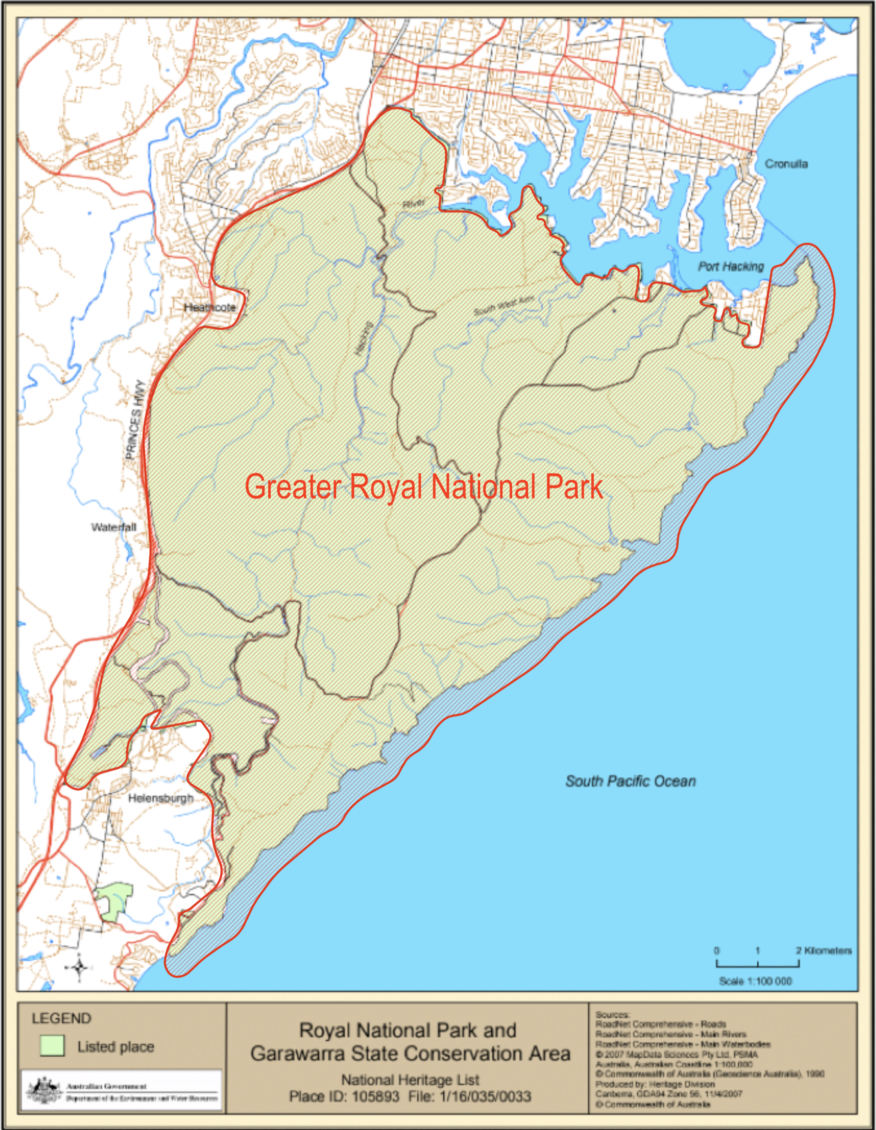
Figure 1: Curtilage map for Greater Royal National Park. Source: National Heritage Listing for Royal National Park and Garawarra State Conservation Area

Boundary description (in words):
The boundary of the GRNP extends to a waterline offset from its Otford to Port Hacking Point coastline. The waterline boundary turns west to follow the Port Hacking and Hacking River shoreline and excludes the villages of Bundeena and Maianbar. The boundary extends north along the western boundary of the suburb Grays Point and turns north-west to follow the southern rear edge of Kirrawee along a creek line. The boundary returns heading south-west, it follows the Princes Highway until south of Waterfall where it separates to follow the Southern Freeway. The boundary continues south to where the two roadways cross-over near Helensburgh. From this point the boundary turns east and then north-east to be rear of Helensburgh and Helensburgh North inclusive of the Garawarra State Conservation Area. The boundary then extends to the Illawarra Railway Line and follows its southern route to a spot just past Lilyvale where the boundary steps east to follow Lady Wakehurst Drive. The boundary extends south along the Drive to a point south of its intersection with Otford Road. This is the southern extremity of the GRNP – from here the boundary returns east to meet its coastal waterline.

Ownership

Name of owner(s):
National Parks and Wildlife Service

Contact person: Ask Ed Beebe

Contact position:

Postal address:

Phone number:

Owner explanation: Nominated at the Landscape Heritage Workshop for the study, 14 March 2016 hosted by MHQ and ALHG for AILA NSW.

Significance

Why is it important in NSW

Statement of state significance

Greater Royal National Park is of State significance in the history of New South Wales as evidence of the magnitude of foresight that the government showed in the late nineteenth century in setting aside the first natural area of land in Australia and establishing the first national park in Australia that has been of great benefit to the people of NSW for the purposes for which it was envisaged and remains so. It is of State significance for its ability to demonstrate 19th century government planning concerning the relationship between parks and recreation, the ‘natural domain’ and the health of the general population.

Royal National Park is of State significance for its association with land reformer Sir John Robertson (1816-1891) five times Premier of NSW. He was responsible for the reservation of National Park and the first Chairman of the Trustees of the Park. It is also associated with early Trustees Sir Henry Parkes Premier at the time National Park was reserved, John Lucas who played a significant role in the creation of public parks and preserving open space throughout the state and Walter Bradley founder of the Zoological Society of NSW.

As the first National Park to be established in Australia in 1879, Royal National Park is of uncommon significance as the beginning of the conservation movement in Australia. The permanent reservation of such a large natural area initiated the development of the National Park systems in New South Wales and Australia.

Greater Royal National Park is of historical significance as a place of Aboriginal cultural significance that survives intact despite proximity to the centre of European colonization. It provides insights into early Indigenous saltwater lifestyle, creative and spiritual engagement with the environment and occupation of the place pre and post contact, indicative activities that display a rich cultural exchange with their natural setting. It may be of State significance for its association with the Dharawal people and for its potential Aboriginal archaeology because of the numerous site types in and around the Reserve with a high possibility of yielding further research findings. Localities within the Park are known by their Aboriginal names.

Royal National Park is of significance as a landmark landscape of spectacular cliff-lined coast and wildflower-rich moors, contrasting woodlands and densely forested inland valleys. Views gained from along its elevated edges, particularly from its south-eastern highpoints and lookouts are of an exceptional high aesthetic quality.

It is of significance for its geographical connections with the other sandstone plateaus of the Sydney Basin and particularly with the uplands and deeply incised valleys and sheer cliffs of the Greater Blue Mountains World Heritage Area. Magnificent areas of sandstone vegetation remain in the GRNP where there is a diversity of vegetation ranging from ‘Coastal Sandstone Plateau Heath’, which contain a high level of floristic diversity to Dry and Wet Scherophyll Forests and ‘Coastal Warm Temperate Rainforest’ in sheltered gullies. It constitutes a major centre of plant species richness, having one of the richest concentrations of plant species in temperate Australia with more than 1000 species. Important patches of rare littoral rainforest survive on the shores of Port Hacking and unusual beds of Hawkesbury Sandstone rocks support rare plant communities.

The Royal National Park (RNP) coastal cabin communities of Little Garie, Era and Burning Palms are of State heritage significance as the largest and most intact groups of vernacular coastal weekender cabins remaining in NSW. Cabin communities were once common along the coast of NSW and the groups at Little Garie (20 cabins), South Era (95 cabins) and Burning Palms (28 cabins) are now rare in the State context and along with the Bulgo group in RNP are likely to represent a small number of similar cabin groups remaining in Australia.

The distinction of Royal National Park is that it was not just for the use of a particular group or class – it was a ‘National’ asset, a cultural and natural landscape to be accessible to all people –Greater Royal National Park is of significance for the entire community of the State and the nation. Its value is demonstrated by the thousands of Australian and international visitors who use the Park each year. In the 1979 centenary year of (Royal) National Park, the Commonwealth and States around Australia recognised the importance of the event.

Comparisons:
Main comparisons:

Ku-ring-gai Chase National Park,
Greater Blue Mountains National Park
Wollemi National Park
Yellowstone National Park
Yosemite National Park

Description:

Existing place or object

The Royal National Park (RNP) is located on the southern rim of the Sydney Metropolitan Area approximately 22 km from the City of Sydney. Within the Sydney Basin bio-region, the RNP forms part of the Hacking River drainage catchment. It is approximately 16000 ha, the majority of which is bushland.

The 2012 SHR nomination for the Royal National Park as a Landscape Conservation Area (National Trust Register Listing Report), was produced by the National Trust of Australia (New South Wales). It is based largely on the work by Dr Geoff Mosley, THE FIRST NATIONAL PARK, A Natural For World Heritage, 2012. This text is highlighted grey.

The Physical Environment of Royal National Park
A. Geology - Rocks and Landforms
Royal National Park is situated in the south-eastern coastal section of the Sydney Basin, a major trough formed during Middle Permian times. More specifically it is located on the northern section of the Woronora Plateau between the coast and the Princes Highway; the northern boundary is the southern shore of Port Hacking, a drowned river valley, or ‘ria’. The base rock of the region was formed by marine sedimentation during the Permian (299 to 251million years ago). Following this, in the late Permian to Triassic (251 to 200 million years ago), large amounts of fluvial material (deltaic and lacustrine) were deposited in the Basin. They include, in order of deposition: the Narrabeen Group some 250 metres thick made up of alternating shales and sandstones (including the Stanwell Park Claystone, the Bulgo Sandstone and the Bald Hill Claystone); the Hawkesbury Sandstone, up to 250 metres thick, though some 170 metres thick over most of the region; and the Wianamatta Shales Group, much of which has been removed by erosion. The Permian-Triassic boundary is near the top of the Wombarra Claystone. The oldest rock outcropping in Royal National Park is the Triassic Stanwell Park Claystone, which means that all the surface rocks are Triassic. The dominant surface rock type of the region is the Hawkesbury Sandstone, a massive crossbedded quartzose coarse-to-medium grained sandstone with strong vertical joints in its horizontal beds. What remains of the Wianamatta Shales is mainly located in the western section of the region from Sutherland through Loftus, Engadine, East Heathcote, and Waterfall.

The rocks in the Narrabeen Group are exposed only where they have been cut into by the headwaters of some of the streams and in a narrow strip on the coastal headlands from Garie to Coalcliff. Five of the eight formations of the Narrabeen Group occur in the Hacking River Valley.

Igneous rocks in the form of dykes - which occur where magmas have been forced up between major vertical joints in the sandstone from Jurassic to Tertiary times - are the final rock-type in the region. The orientation of the dykes follows the joint structure of the rocks intruded by the magma. Quaternary age clifftop sand dunes occur along the coast from Jibbon to Burning Palms.

The presence of quartz-siderite cement in the grains of the Hawkesbury Sandstone means that it has a low permeability, especially vertically. Cliffs are common where the Hawkesbury Sandstone is underlain by shaly Narrabeen Group sediments or is attacked by wave action.

The major events responsible for the geology of the region are: the existence of the Sydney Basin, a major physiographic feature; the uplift of the mountains in the surrounding areas and their erosion to create the deposition of sediments in the Basin; and the Basin's uplift and erosion, especially the down-cutting of the streams during an uplift in the late Triassic. The Sydney Basin has a saucer-like shape with the highest slopes in the west. Because there are no marine fossils in the Hawkesbury Sandstone, it is conjectured that deposition took place by means of rivers flowing through huge deltas into a large lake.

Conaghan (1980) has provided a detailed account of the stratigraphy of the Hawkesbury Sandstone and the origin of the massive sandstone facies, comparing the depositional environment with that occurring today on the lower part of the Brahmaputra River. Branagan (2000) suggests that it was similar to the modern channel system of Cooper Creek and the Diamantina River in Central Australia. These Channel Country streams flood areas of interlocking channels 40 kilometres wide; and while they now deposit muds, they once carried sandy loads under the wetter conditions of the Pleistocene. According to Young and Young (2006) some geologists believe the upper beds of the Hawkesbury Sandstone were deposited in estuarine areas near ancient seas.

1. Landforms
The main landform of the region is the Woronora Plateau, one of six plateaus in the Sydney
Basin. It is complemented to the north by the Hornsby Plateau. The Woronora Plateau takes the form of a ramp with a slight dip downwards to the north. The ramp is also slightly tilted
downwards from the coast to the west. According to Young and Wray (2000) this tilting occurred no later than the mid-Tertiary. The northern part of the Plateau in Royal National Park is dissected by the gorges of the Hacking River and its tributaries and estuary, Kangaroo Creek, South West Arm Creek and Cabbage Tree Creek. The altitude of the main Plateau surface in Royal National Park varies from some 200 metres above sea level in the south to sea level in the north at Jibbon Point. Further south the Woronora Plateau reaches its highest point of 600 metres near Robertson. The Illawarra Escarpment, a dominant feature to the south of the region, has its northernmost beginnings in Royal National Park, at either Jibbon Point or the higher cliffs of Garie Headland and the Garawarra Ridge on the region's southern coastline, but the Escarpment is a relatively lesser topographic feature at this point. Behind Wollongong the Escarpment is 500 metres high.

The northward dip of the ramp helps to explain the northward-flowing direction of the Hacking River. Another factor is the joints in the Hawkesbury Sandstone known as 'lineaments'. These are long lines of joints formed by stresses in the rock when it was laid down and during the uplifting of the Woronora ramp. They are easily seen on aerial photographs, especially those taken after a fire and on images taken from satellites. Many of the lineaments run from north to south and north-east to south-west, others at right angles - north-west to south-east. They have captured the run-off and directed the flow of the rivers and creeks. The course of the Hacking River runs along a major stress feature, the Helensburgh Lineament, running north-east from Stanwell Tops. In its headwaters in the south the Hacking River has cut through to the softer Narrabeen Group rocks where they are closer to the surface, resulting in its valley being wider in its upper course than in its lower where it passes through the deeper more resistant Hawkesbury Sandstone - creating what is known as a 'bottleneck' situation similar on a smaller scale to the course of the Grose River Valley in the Blue Mountains to the north-west.

Another major landform feature of the Royal National Park is the many cliffs formed on vertical fractures in the Hawkesbury Sandstone, both on the coast and in the valleys. The large horizontal blocks of sandstone collapse through the effects of gravity once they have been undercut by a third of their length. The presence of underlying softer shales plays apart in the undercutting. The height of the cliffs increases southwards with the rise in the Hawkesbury Sandstone from sea level at Jibbon Point in the north to over 100 metres in the south.

Several of the flat surfaces, clearly visible along the coastal section, coincide with the bedding planes in the Narrabeen Group and Bulgo Sandstone series. With the harder Hawkesbury Sandstone measures resting on softer rocks in the south, the coastal landforms in this section are more complex. Caves in the sandstone appear to owe their existence largely to chemical erosion.

On the northern shore of Curracurrang Cove, the rocky clifftop is a flat sandstone bench 25
metres above the water and bare of vegetation, soil and boulders. It is likely that the bench has been stripped of its cover by huge waves sweeping across it. Being well above the level reached by the most severe storm waves, its most likely cause is a tsunami coming onto the coast from the south-east and sweeping over the bench (Young and Young, 2006).

The valley of Toonoum Brook (near Sir Bertram Stevens Drive) is filled with broken rock of all sizes from small to very large boulders. There are several major well vegetated debris dams across the brook that divert its flow around them. The Toonoum Cave on the northern side of the valley has been formed by the collapse of a sandstone cliff which overhung a shale outcrop burying the overhang and forming an underground cave used as a nursery cave by bats. The flatter parts of the Woronora Plateau in Royal National Park are those that are cut only by shallow headwater streams above the deeper gorges where most fluvial erosion is concentrated. Bogs have been formed in broad shallow depressions in these relatively impermeable parts of the Hawkesbury Sandstone. Radio-carbon dating has shown that sedimentation in these 'dells' began some 17,000 years ago.

A legacy of the major sea level change of the Holocene which resulted in the approximate
current height and location of the sea being reached some 6,000 years ago is the drowned
valley of Port Hacking and its inlets. At the height of the last glaciation some 20,000 years ago the sea level was some 7 kilometres further east.

2. Major Rock Types
a. Hawkesbury Sandstone Rocks.
This is the major rock-type of Royal National Park and was deposited on top of the Narrabeen Group. In the Sydney Basin it extends for about 100km radius from Sydney and has a maximum thickness of 250 m. It consists of glistening grains of quartz (sand) held together by cement Quartz is the main constituent of granite (an igneous rock), which provided the ultimate source of sediment for the Sydney Basin. The quartz grains are cemented with iron and aluminium minerals which weather to form the clay component of the sandy soil. Iron is the cause of the colouring in the sandstone, as quartz crystals are colourless.

Hawkesbury Sandstone rocks consist mainly of sand-sized quartz grains (60-70%), cemented together with clays (20-30%). Pebbles and conglomerate are present at the base of some beds. A small percentage of iron oxides gives it characteristic and often banded colours of yellow, orange, pink and dark red. The banding is called Liesegang Rings. The coloured rings were formed by water moving through the rock mass, probably when the original damp sediments were being compacted into solid rock This water carried dissolved iron oxide and some of this precipitated out in a diffusion pattern, giving abstract designs of coloured (iron oxide rich) rings across the pale (iron oxide depleted) rock.

The Hawkesbury sandstone rocks are very low in plant nutrients such as phosphorus, nitrogen, zinc, manganese and molybdenum, and support very low nutrient soils. Hawkesbury Sandstone rock is a moderately strong rock and so it can stand in high cliffs. It is strongly jointed, with vertical joints (fractures) that extend down through several beds (layers) within the rock. These joints and the horizontal beds, divide the sandstone into large blocks, which can break away from a cliff to leave a vertical face. The blocks may lodge in the landscape somewhere downslope as floaters, which may continue to move slowly under the influence of gravity. The cross-bedded sandstone separates into sandstone plates along the cross-bedded planes.

The Hawkesbury Sandstone Series are excellent hosts for the retention of water, but in general they have low transmissivity. In the Hacking River catchment, the rock is generally more pervious and jointed than in many other areas, and may sustain a flow to streams over much of an average year. The lower primary porosity of the massive facies reduces the flow of water through them other than through joints and they may form a barrier to the downward flow of groundwater. The groundwater may run along the top of these beds under the ground until it can find its way lower through jointing in the rock. Where the rock approaches the surface the water table may create swampy patches, of irregular sizes, depending on weather conditions; they are important as contributors to the pattern of vegetation over the landscape. The upland swamps have been formed in this way. Lithosere plant communities occur on many flatter rock outcrops, a good example being the Moss Gardens along the Wise's Track. Characteristic features of the sandstone weathering are the formation of honeycombing and caves. Caverning and honeycombing is common in cross-bedded and massive facies.

b. Narrabeen Series Rocks.
Rocks of the Narrabeen Series outcrop in the upper part of the Hacking River valley, in the southern part of Royal National Park. These rocks can be seen to emerge from the sea in the cliff-line at Curracurrong, gradually rising to the south where they form a significant part of Garie Head. The first rocks to outcrop are the relatively nutrient-rich and readily erodible distinctive purple-red shales of the Bald Hill Claystones (once known as chocolate shales), which are underlain by the Bulgo Sandstones and the Stanwell Park Claystones all laid down in the early Triassic. They were most likely laid down in marine muddy estuaries by streams carrying mixed loads of clays and sands. Narrabeen rocks do not outcrop in Heathcote National Park.

c. Wianamatta Series Rocks.
Wianamatta Series Rocks were laid down in the area towards the end of the Triassic Period. These largely shale rocks came from alluvial, estuarine and beach sediments. Most of the Wianamatta rocks have been eroded from the Woronora Plateau and only small outcrops occur in the area along the western boundary of Royal National Park. There is some contention as to whether the shale outcrops in Royal National Park at Loftus are Wianamatta Series rocks or unusual beds of Hawkesbury Sandstone rocks. Either way the plant communities they support are rare and significant.

d. Quaternary Dune Deposits.
The relic clifftop dunes between Bundeena and Burning Palms are extensive and well- preserved examples of aeolian coastal dunes. They have additional complexity due to the modern aeolian deposition. They occur at Bundeena, Jibbon and on to Marley, Little Marley, Wattamolla, Curracurang, Garie Headland, Garie, Little Garie, North and South Era and Burning Palms. They have an uncertain origin. Carbon-14 dating suggests those at Jibbon are at least 10,000 years old. Dunes to the north on the Kurnell Peninsula have been dated as ranging from 14 to 26,000 years ago (Bryant et al, 1994). Young and Young (2006) say the dunes on the clifftops line up with the dominant south to south-easterly onshore winds, but it is uncertain how the masses of sand got to their present location. Perhaps they formed under an earlier wind regime and have been reshaped under the present wind regime. Perhaps sand that has weathered on the plateau and accumulated as sand sheets or in swamps has been exposed and shaped into dunes. Old buried soils exist, indicating reactivation in the past.

B. Soils
The soils of Royal National Park are closely related to the underlying rock-types. Those on the Hawkesbury Sandstone, which is the major base rock of the region, derived from the weathering of the coarse grained quartzitic material, are thin, acidic, contain few minerals and are relatively infertile, being especially deficient in the essential plant nutrients nitrogen and phosphorous. Most of these soils are classified as Tenosols. There are also some patches of lateritic soils (Ferrosols, rich in iron) on the surface of the Hawkesbury Sandstone, usually on the higher ridges. These are the result of deep weathering of a once more-extensive coverage of laterite of uncertain age. Patches of weathered igneous rocks such as that at Tall Timbers near Bundeena (Young and Young, 2006) are relatively fertile. Patches of weathered shale lenses throughout the sandstones also give rise to nutrient-rich soils. In contrast to the soils occurring over most of the Hawkesbury Sandstone, the clayey shale soils (Kurosols and Kandosols) of the Narrabeen Group, wherever they have been exposed by erosion in the Upper Hacking River Valley and along the coast between South Era and Burning Palms, are deeper, moister, and better-aerated. Having a higher nutrient status, they are more fertile. These beds are often referred to as ‘chocolate shales’ and show a wide range of colour. There are outcrops in a disused quarry opposite the southern end of Lady Carrington Drive.
On the more restricted Wianamatta Shale Group rocks, the dominant soil type is a podsolic
sandy to silty clay loam (Kurosols). This is usually hard-setting, and of moderate acidity and
fertility, and it mostly occurs outside Royal National Park.
The broad soil picture is completed by reference to the richly organic sandy sediments
accumulated in the largely treeless upland dells (Organosols) and the Podosols of the ancient sand dunes.

C. Climate
The climate of Royal National Park is strongly influenced by its mid-latitude position of 34 degrees south and its coastal location. In the Koppen classification the area is described as having a "humid mesothermal type climate" and belonging to a "moderate oceanic climate province". In other words, the region has a temperate climate with a maritime influence. This influence prevents extremes of temperature, and the mean temperature range of the area varies from an average January maximum of slightly over 26 degrees centigrade to an average July minimum of under 7 degrees. Frosts are rare. The upland nature of the plateau, although not high, nevertheless helps to intercept the air masses coming in from the Pacific Ocean. 'The highest average rainfall occurs in late summer
and autumn but there are appreciable falls throughout the year. The highest average falls are in the higher areas in the south (Helensburgh 1444mm); generally annual falls are in the range 1100-1200mm. The climate of the region can be summarised as having a warm wet summer-autumn period and a drier winter and spring. The sheltered conditions of the major valleys and the deep gullies have created micro-climates in these situations.

D. Natural Vegetation
The natural vegetation of Royal National Park is characterised by the great variety of plant communities which exist in a relatively small area. This is largely due to the coastal location and the incision of the Hacking River through the Hawkesbury Sandstone Plateau rocks into the rocks of the Narrabeen Group below. Not only are the soils on the latter rocks more fertile but the dissection has created sheltered conditions. Study of the vegetation of the Permian-Triassic sequence led Beadle (1954 and 1962) to suggest that the vegetation was controlled by soil phosphate with the vegetation units reflecting the varying phosphate status of the parent materials. Where phosphate levels were highest (the Narrabeen Shales) the vegetation tended to be tall open forest, or, in the more sheltered locations, rainforest.
On the Hawkesbury Sandstone or truncated laterite with lower phosphate levels, xeromorphic woodlands and scrubs were dominant. As a result of these highly contrasted conditions of aspect, moisture, soil texture, depth and nutrient availability, along with the incidence of fire, the plant communities range from heathlands to dry sclerophyll woodlands and dry sclerophyll forests to wet sclerophyll forests and rainforests. The variety evident within each of the major vegetation groupings - heathlands, dry sclerophyll woodlands, dry and wet sclerophyll forests, rainforests and others - is also evident in the individual components of each. Keith and Tozer (2011) have recently developed a new model of vegetation succession for the coastal sandstone plateaus in the Sydney Basin; it provides insight into vegetation succession in Royal National Park. The most comprehensive compilation of plant species and other aspects of the biota of Royal National Park is that by Bob Crombie and Alan Fairley (2007) which also contains lists of fungi and bacteria and other microorganisms. Specht (1981) in his Major Vegetation Formations in Australia classified the vegetation of Royal National Park as 'Eucalypt open-forest to woodland (with grassy understorey)'. This formation is widespread in South Eastern Australia, Tasmania and South Western Australia. For the purpose of Australia-wide comparison the best source is The Conservation Atlas of Plant Communities in Australia (Specht et al, 1995). This comprehensive source contains 910 maps showing the distribution of 921 communities (344 major and 577 minor); on the basis of structure and major diagnostic species, thereby presenting a community-based vegetation regionalisation of Australia. 13 communities area listed as occurring in Royal National Park (Find Appendix A1). With regard to the great variety of vegetation types in the region the most up-to-date classification allowing comparison with other parts of South Eastern New South Wales, is the report and maps in Native Vegetation of Southeast NSW : a revised classification and map for the coast and eastern tablelands, published in Cunninghamia (Tozer et al, 2010). This classifies the vegetation of the region into 191 floristic communities of which 25 of the communities are shown to occur in Royal National Park.

1. Heath.
Heath communities dominate the shallow soils of the exposed Hawkesbury Sandstone Plateau surface of the eastern part of Royal National Park. The most extensive heath community in the region is the 'Coastal Sandstone Plateau Heath.' Its heaths are characterised by open to dense shrub canopies and emergent mallee eucalypts. 'Coastal Rock Plate Heath' occurs on skeletal soils. At the other end of the spectrum, where drainage is impeded, it is replaced by 'Coastal Upland Swamp', characterised also by peaty soils. The
'Coastal Plateau Sandstone Heath' community is interspersed with 'Coastal Sandstone
Ridgetop Woodland' where the soils are somewhat deeper than in the surrounding heathland. 'Sandstone Headland Scrub', characterised by dense scrub, is restricted to coastal headlands and is often found clinging to cliff surfaces. 'Coastal Sandplain Heath' is restricted to podsolised sand dunes generally perched on the plateau surface. In spite of their relatively low fertility these coastal heath communities are characterised by a high level of floristic diversity.

2. Dry Sclerophyll Forest.
Dry Sclerophyll Forest is the main forest vegetation type on the Hawkesbury Sandstone. Reference has already been made to the 'Coastal Sandstone Ridgetop Woodland' which in Royal National Park occurs mainly on ridges surrounded by heath and in some places in association with the 'Sydney Shale Ironstone Cap Forest'. The 'Coastal Sand Forest' is found in small areas in sheltered deep sands on beach hind dunes, coastal flats and sandstone headlands. 'Coastal Sandstone Gully Forest' occurs on the lower slopes of sandstone gullies and is often intermediate to 'Coastal Sandstone Ridgetop Woodland' on the upper slopes, and 'Sandstone Riparian Scrub' occurring in narrow strips along creek lines. Further inland, where rainfall is lower with distance from the coast, its place is taken by 'Hinterland Sandstone Gully Forest'. The 'Sydney Shale-Ironstone Cap Forest' occurs on Wianamatta Shale lenses and ironstone mantles on ridges near the western boundary of Royal National Park and in a narrower band above the clifftops of the narrower Garawarra Ridge.

Another eucalypt-dominated forest type is the 'Cumberland Sandstone Shale Transition Forest'. It occurs on the boundary between the Wianamatta Shale and Hawkesbury Sandstone and shows similarities with the 'Sydney Turpentine Ironbark Forest'.

3. Wet Sclerophyll Forest.
Tall Wet Sclerophyll Forest occurs in three main communities in Royal National Park. Probably, the best known is the 'Sydney Turpentine Ironbark Forest' which occurs naturally on the soils derived from the Wianamatta Shale Group on the western side of Royal National Park from Sutherland to Darkes Forest including the Loftus Ridge. 'Warm Temperate Layered Forest' occurs on sheltered slopes in gullies and on escarpments, commonly adjoining rainforest; it may contain rainforest taxa below its eucalypt canopy; with higher soil fertility it grades into 'Illawarra Gully Wet Forest'. Tall Blackbutt, Ironbark, Turpentine and Blue Gum trees are common.

4. Rainforest.
Royal National Park also contains areas of warm temperate and littoral rainforest which represent the northernmost extension of the rainforests of the Illawarra region to the south. The most favoured sites for these are the Narrabeen Group shales in the sheltered valleys of the Hacking River and Bola Creek and in sheltered gullies on the escarpment south of Garie. There are two main types: ‘Coastal Warm Temperate Rainforest' is a closed forest found on clay loam soils in the sheltered gullies and on sheltered escarpment sites, whereas the 'Temperate Littoral Rainforest' occurs at Marley on sand dunes and in a narrow coastal belt between Curracurrong and Otford. It is best recognised in the forest at Palm Jungle near Burning Palms; reflecting littoral influences, it shares some species with subtropical rainforest types. The region is the southern limit of many subtropical rainforest species on the East Coast. Important patches of rare littoral rainforest occur on the shores of Port Hacking. Topographic refugia support patches of rainforest throughout Royal National Park in otherwise unsuitable conditions, adding to the area's biodiversity. These are often in the lee of a cliff-line or in a steep cliff lined valley where it ends in a waterfall. Excellent examples occur at Curracurrang, Flat Rock and Gundamaian.

5. Wetlands.
There is a wide range of wetland vegetation types in the region, from estuarine
wetland along the Port Hacking shore to freshwater swamps in dune depressions and sedge dominated swamps in upland sandstone valleys. The communities include: 'Coastal Freshwater Lagoon' (at Jibbon and Marley); 'Estuarine Saltmarsh'; 'Estuarine Mangrove Forest'; 'River Mangrove' and 'Estuarine Fringe Forest (in the Hacking River Estuary). Wetland forest types occurring in the region include 'Floodplain Swamp Forest' and 'Estuarine Creekflat Scrub' which occurs on the shores of estuarine lagoons, wetlands and creek flats. 'Coastal Upland Swamp' vegetation is typically found on the poorly drained headwaters of the creeks where peat soils have accumulated. Examples are the Uloola Swamp in Royal National Park.

6. Grassland
It is not clear whether 'Headland Grassland' in the region is a natural community. According to David Keith (communication with Geoff Mosley) its presence on headlands at Garie and Era may be largely the product of the burning, clearing and grazing of the 'Sandstone Headland Scrub'.

7. Scleromorphic Features and Species Richness.
The effect of the combination of low-nutrient status soils, periodic drought, burning; and geographic isolation over a long period of time is responsible for the unique scleromorphic adaptations occurring in the vegetation and it has allowed a large number of species to survive in Australia. The natural vegetation of the Royal National Park provides a classic example of this scleromorphy. Royal National Park is also a major centre of plant species richness, having 1,130 species (Crombie and Fairley, 200&). This wide array of species includes heaths (Ericaceae), peas and wattles (Fabaceae and Mimosaceae), grevilleas and banksias (Proteaceae) and members of the eucalypt family (Myrtaceae).

E. Fauna
The diverse vegetation of Royal National Park has provided a wide range of habitats for native fauna. Among these many habitats, the rainforest and wet sclerophyll forests of the Hacking River catchment support the greatest number of mammal and bird species. Fire is a major factor affecting species and populations. A comprehensive vertebrate fauna survey of the region in the summers 1995-96 and 1996-97 identified 247 species of native vertebrates comprising 164 birds, 37 reptiles, 30 mammals and 16 frogs. Within all these numbers, 14 threatened species were found (Andrew, 2011). The surveys followed an extensive wildfire in January 1994 and the number of species sighted was well under the 358 species known from the region before the wildfire. A 2009-10 fauna survey produced a total count of 347 species (Schulz, M. and Magarey, E., 2011) and included several previously undocumented species. It also found that some 17 previously identified vertebrate species including the Ground Parrot, Parma Wallaby and Greater Glider could no longer be located.

Although there has not been a systematic survey of mammals in the region, the February 2000 Plan of Management reported that Royal National Park supported at least 29 species of native mammals as well as 10 species of bats. It also reported that several species including the Tiger QuaIl (Dasyurus maculatus) and the Red-necked Pademelon (Thylogale thetis) had undergone a marked decrease in numbers. Greater Gliders were sighted in Royal National Park and Stanwell Tops in 2012.

Royal National Park is notable for having a rich avifauna, with 143 regular resident or nesting species and a further 33 offshore species. The Cabbage Tree Basin and the estuarine sandbar and sand dunes in the Simpsons Bay and Maianbar area provide habitat for a number of migratory birds including the Eastern Curlew (Numenius madagascariensis), the Great Egret (Ardea alba) and the Pied Oyster Catcher (Haematopus longirostris). Several previously recorded species occurring in Royal National Park include the Emu (Dromaius novaehollandiae) and Diamond Firetail Finch (Emblema guttata).

The diversity of the region's habitats is also reflected in an abundant and diverse reptile and frog fauna. 40 species of reptiles and 30 species of amphibians were recorded in Royal National Park and the immediate vicinity in the 2000 Plan of Management. The most important habitats for reptiles and frogs are the rainforests and other wet forests along the Hacking River and the Garawarra Ridge, the coastal heaths and the freshwater swamps. The Jibbon Swamp is a breeding place for the Eastern Snake-necked Turtle (Chelodina longicollis). The swampy dells provide ideal conditions for the Small Swamp Crayfish (Euastacus keireiensis). Rock outcrops provide important habitat for the rare Broad-headed Snake (Holocephalus bungaroides).

Royal National Park has a rich invertebrate fauna and a diverse terrestrial mollusc population. The most important areas for the molluscs are the Hacking River rainforests of the Hacking River valley and the Garawarra Ridge including Middle Rill and Palm Jungle. A recent study of aquatic micro-invertebrates in the freshwater coastal lagoons of Marley and Jibbon identified 12 taxa.

The main facilities, highlights, significant places and walks within the Greater Royal National Park include: The Coastal Walk, Uloola Walking track, Wattamolla and picnic area, the Bonnie Vale campground, the Bundeena Drive to Marley walk, the Forest-path walk, Hilltop Cottage, the Karloo walking track, Lady Carrington Drive, Loftus Loop Trail, North Era and campground, Weemalah Cottage, Werrong Beach and track, Wedding Cake Rock, Couranga walk track, Curra Moors and loop track, Garie Beach and picnic area, Palm Jungle and loop track, RNP Visitor centre, Figure Eight Pools, Bonnie Vale and picnic area, Bungoona lookout and path, Currawong Flat and picnic area, Governor Game lookout, Gunjulla Flat and picnic area, Ironbark Flat and picnic area, Pool Flat and picnic area, Red Cedar Flat and picnic area, Reids Flat and picnic area, Uloola Falls and campground, Upper Causeway and picnic area, Warumbul picnic area, Waterfall Flat and picnic area, Wattle Forest and picnic area, Reids Flat Cottage and Audley Dance Hall Café.

Integrity / intactness:
High level of integrity

Modifications date:

Date you inspected the place for this description: 12 January 2018

Current use: National Park

Original or former use: Crown land.

Further comments:
SHR items within RNP
Dharawal Resting Place – Costens Point, LALC – La Perouse, LGA – Sutherland, gazetted 2005
Dharawal Resting Place – Middle Rill, LALC – La Perouse, LGA – Sutherland, gazetted 2010.
Dharawal Resting Place – North Era Beach, LALC – Illawarra, LGA – Wollongong, gaz. 2005.
Audley historic recreational complex, LGA – Sutherland, SHR 00976.
Royal National Park Coastal Cabin Communities – LGA Wollongong, SHR 01878.
LEP items on State Heritage database but not listed on schedule 5
Royal National Park

Below:
Sutherland Shire LEP, 2012, Schedule 5, Environmental Heritage showing results for RNP (2/3/2018).
Royal NationalPark | Historic recreational complex, comprising Audley Group | Junction of Audley Road and Sir Bertram Stevens Drive |  |  | MGA Zone 56, 320656.03°E, 6227853.95°N |  | State |  | 3402
Royal National Park | Historic recreational complex, comprising house | Audley Road/Sir Bertram Stevens Drive, eastern side of road, on western approach to Audley Weir |  |  | MGA Zone 56, 320590°E, 6288030°N |  | Local |  | 3403
Royal National Park | Historic recreational complex, comprising ranger’s cottage | Audley Road/Sir Bertram Stevens Drive, corner of Lady Carrington Drive |  |  | MGA Zone 56, 320625°E, 6227710°N |  | Local |  | 3404
Royal National Park | Historic recreational complex, comprising shelter pavilion | Audley Road/Sir Bertram Stevens Drive, corner of Lady Carrington Drive |  |  | MGA Zone 56, 320650°E, 6227800°N |  | Local |  | 3405
Royal National Park | Deeban spit—sand spit | Extending from Bonnie Vale towards Burraneer Headland |  |  | Part of Lot 50, DP 48305 |  | Local |  | 3406
Royal National Park | “Chaldercot”—house | On foreshore between Dark Bay and Carruthers Bay |  |  | MGA Zone 56, 324800°E, 6228850°N |  | Local |  | 3407
Royal National Park | Avenue of trees, consisting of Bunya Pine, Hoop Pine and Monterey or Radiata Pine | Royal National Park entry at Loftus Junction and extending into Royal National Park |  |  | MGA Zone 56, 320395°E, 6230185°N |  | Local |  | 3408
Royal National Park | Ballast shoal | Port Hacking mid channel between Little Turriell Bay and Yennibilli Point (just north-west of Maianbar) |  |  | MGA Zone 56, 326800°E, 6228100°N |  | Local |  | 3410
Royal National Park | “Bedford”—cottage | Princes Highway (on edge of Royal National Park) |  |  | MGA Zone 56, 320260°E, 6230630°N |  | Local |  | 3401
Royal National Park | Former “Gardeners Garage” | Princes Highway (on edge of Royal National Park) |  |  | MGA Zone 56, 320244.89°E, 6230659.66°N |  | Local |  | 3411
Royal National Park | Rock formation, described locally as “Pulpit Rock” (minor) | On foreshore west of Red Jacks Point |  |  | Lot 1, DP 744531 |  | Local |  | 3412
Royal National Park | Boat sheds | Warumbul Road (Gogerly’s Point) |  |  | Lot 2, DP 3274 |  | Local |  | 3413
Royal National Park | Rotunda | Warumbul Road (Gogerly’s Point) |  |  | Lot A, DP 361390 |  | Local |  | 3414
Royal National Park | Timber cottages | Warumbul Road (Gogerly’s Point) |  |  | Lot B, DP 361390 |  | Local |  | 3415
Royal National Park | “Gogerly’s Cottage” | Warumbul Road (Gogerly’s Point), adjacent to “Hilltop” |  |  | Lot 2, DP 3274 |  | Local |  | 3416
Royal National Park | “Rathane” cottage, associated buildings and landscape setting | Warumbul Road (Gogerly’s Point), north of “Hilltop” |  |  | Lot A, DP 361390 |  | Local |  | 3418
Royal National Park | “Telford” and landscaping | Warumbul Road (Gogerly’s Point), including west of “Rathane” |  |  | Part of Lot 21, DP 57765 |  | Local |  | 3417
Royal National Park | “Hilltop” and landscaping | Warumbul Road (Gogerly’s Point), south of “Rathane” |  |  | Lot 2, DP 3274 |  | Local |  | 3419
Royal National Park | Gardens/grounds | Warumbul Road (Gogerly’s Point), within landscape setting for “Rathane” |  |  | Lot A, DP 361390 |  | Local |  | 3420
Royal National Park | “Warumbul”—remnant period garden and ancillary foreshore structures in grounds | Warumbul Road (Warumbul) |  |  | MGA Zone 56, 324950°E, 6227740°N |  | Local |  | 3421
PART 2 Archaeological sites
Royal National Park | Stone work on road, 300m from the visitors centre |  | Artillery Hill, crosses Winifred Falls Track | MGA Zone 56, 320720°E, 6227570°N |  | Local |  | A3422
Royal National Park | Audley Historic Recreational Complex, comprising: Audley group |  | Junction of Audley Road and Sir Bertram Stevens Drive | MGA Zone 56, 320656.03°E, 6227853.95°N |  | Local |  | A3423
Royal National Park | House sites and associated remains |  | On western side of Costens Point | Lots 1–19, DP 12359; Lot 5, DP 4466 |  | Local |  | A3425
Royal National Park | Old Coast Road |  | Commencing north-west of sites at Costens Point | Lots 1–19, DP 12359 and unidentified land between Maianbar Road and DP 4466 (Royal National Park) |  | Local |  | A3426
Royal National Park | Access stairs to jetty and boat shed—“Chaldercot” |  | Deer Park Road (Deer Park) | Lot 8, DP 57765 |  | Local |  | A3427
Royal National Park | Military parade site |  | From Farnell Avenue west to Loftus Ridge Bottle Forest Road | MGA Zone 56, 319485°E, 6229490°N |  | Local |  | A3428
Royal National Park | Fosters Flat saw pit |  | Eastern side of Fosters Flat, above creek, 350m north of Couranga Track | MGA Zone 56, 317650°E, 6219540°N |  | Local |  | A3429
Royal National Park | Former clay pit associated with railway contractors |  | East of Illawarra railway line and northern end of Wilson Parade | MGA Zone 56, 316600°E, 6227540°N |  | Local |  | A3430
Royal National Park | Shell grit beach mine |  | On Jibbon Beach 200m south-west of Jibbon Head | MGA Zone 56, 330895°E, 6227845°N |  | Local |  | A3432
Royal National Park | Plaque |  | Erected in cliff face at Jibbon Head | MGA Zone 56, 331035°E, 6227990°N |  | Local |  | A3431
Royal National Park | Lady Carrington Drive group, including the roadway, sandstone cobblestone paving and Mullion Brook (unlocated site of former Ranger’s Cottage) (including stone embankment wall on west side of road 8–9 courses high. Jersey Springs, 2 identical stone basins, 0.69cm × 0.55cm, on western side of road, incised deeply with the lettering JERSEY SPRINGS 1892. Each basin fed by spring water flowing from coursed stone-lined drain at bases of basins. Lady Carrington Bower and Kobardo Brook. On east side of road brick basin 0.58cm × 0.58cm, depth 0.33cm, set below rock cut pool. Adjacent flight of 8 small steps lead to lower pool, on western side of which is stonework for culvert across Kobardo Brook. Culvert constructed of squared sandstone blocks up to 6 courses high, with one course forming capping on top. Width of culvert 4.48m (14 feet). On west side of culvert stone steps led down to brook below. |  | Lady Carrington Drive, from Audley to Sir Bertram Stevens Drive | MGA Zone 56, 320155°E, 6223730°N |  | Local |  | A3433
 | Now damaged. South of Lady Carrington’s Bower on east side remains old steps—3 are visible. 200m north of Calala rectangular sandstone remain in setting for 22.35m. For most of distance one block wide, at northern end two visible lying adjacent. To east are remnants of small stone cobbles. South of Karani Brook quarry site on east of road. North of Bola Creek quarry site on East side of road. Entrance gates, Lady Carrington Drive, south end. Two stone piers each with 4 bolts protruding from concrete on top, which originally held wrought iron lyre birds forming arch (not extant). Concrete dated 20.12.63 A.W (oral informant: Albie Weigland) Curved parallel stone walls on either side of gate with central depression for flower beds. Style of stonework construction not seen elsewhere in Lady Carrington Drive sites—rectangular flat stones with thick mortar—strong horizontal emphasis. Leterite quarry opposite entrance gates, on east side of road.
 | Quarry face c. 15m high, extends some 70m in length. Cuttings in rockface indicate quarrying both Laterite gravel and stone. East Lady Carrington Drive formerly continued through quarry site opposite entrance gates for further two miles to the original park boundary. This section is now part of Lady Wakehurst Drive.)
Royal National Park | Florence Parade |  | Commencing at Grays Point and terminating at Lady Rawson Parade | MGA Zone 56, 321440°E, 6229450°N |  | Local |  | A3434
Royal National Park | Bundeena/Maianbar water supply |  | 50 Maianbar Road to Cabbage Tree Basin | Lot 1, DP 444458 and unidentified land between Maianbar Road and Bundeena Drive |  | Local |  | A3424
Royal National Park | Remains of landscape and jetty |  | Point Danger on western side of Gundamaian | MGA Zone 56, 323900°E, 6228820°N |  | Local |  | A3436
Royal National Park | Site of landscaping and jetty remains |  | Point Danger on western side of Gundamaian | MGA Zone 56, 323800°E, 6229020°N |  | Local |  | A3435
Royal National Park | Rawson Drive, including site of bridge across tributary of Temptation Creek |  | Rawson Drive, 200m east of tram line | MGA Zone 56, 320500°E, 6230060°N |  | Local |  | A3438
Royal National Park | Rawson Road Group—road (including small sandstone cobblestones) |  | Rawson Drive, east of Illawarra railway line, beside fire trail | MGA Zone 56, 320390°E, 6230240°N |  | Local |  | A3439
Royal National Park | Remains of house sites |  | Red Jacks Point | Lot 1, DP 744531 |  | Local |  | A3440
Royal National Park | End of Simpsons Road, Simpsons Hotel site, sandstone remains, sea wall and Norfolk Island Pines |  | End of Simpson Road | Lot 162A, DP 10317 |  | Local |  | A3442
Royal National Park | Remaining Bonnie Vale cabins, generally fibro, tin and timber frame |  | End of Simpson Road | Part Lot 6, DP 752065 |  | Local |  | A3441
Royal National Park | Remains of jetty |  | Wants Point on eastern side of Gundamaian | MGA Zone 56, 324640°E, 6229230°N |  | Local |  | A3443
Royal National Park | Warumbul |  | North of Graham’s Point, Warumbul Road | Part Lot 20, DP 57765 |  | Local |  | A3444
Royal National Park | “Telford”—house and landscaping |  | Warumbul Road (Gogerly’s Point), including west of “Rathane” | Part Lot 21, DP 57765 |  | Local |  | A3445
Royal National Park | Gogerly’s Point |  | Warumbul Road (Gogerly’s Point) | Part Lot 21, DP 57765; Lot 5, DP 3274; Lot 4, DP 3274; Lots A and B, DP 361390; Lot 2, DP 3274 |  | Local |  | A3450
Royal National Park | “Gogerly’s Cottage” |  | Warumbul Road (Gogerly’s Point), adjacent to “Hilltop” | Lot 2, DP 3274 |  | Local |  | A3447
Royal National Park | “Lamont”—house site |  | Warumbul Road (Gogerly’s Point), east of “Hilltop”, | MGA Zone 56, 325100°E, 6228110°N |  | Local |  | A3449
Royal National Park | “Rathane” cottage and associated buildings and landscape setting |  | Warumbul Road (Gogerly’s Point), north of “Hilltop” | Lot A, DP 361390 |  | Local |  | A3446
Royal National Park | “Hilltop” and landscaping |  | Warumbul Road (Gogerly’s Point), south of “Rathane” | Lot 2, DP 3274 |  | Local |  | A3448

Historical outline:

Origins and historical evolution

Formation:
Sandstone geology laid done in the Early and Mid Triassic Period, from about 250 to 235 million years ago.

Designer / architect: Prehistory

Maker / builder:

Historical outline of place or object:

Aboriginal History

Evidence of the thousands of years of living by Aborigines in the region is widespread in the environment and takes many forms. One of the most obvious records of the long-term Aboriginal occupation is the existence of substantial shell midden deposits at many sites along the coastline and in rock shelters. On the coast, major shell middens occur behind the beaches at Garie (Middle Rill) and North Era as well as along the shoreline of Port Hacking.

There are also many surviving examples of Aboriginal art in the region including paintings,
drawings and sandstone engravings, usually of food sources such as eels and of totems.
Depictions of whales, a major totem of the Dharawal, are a distinctive feature of the area,
examples occurring in engravings around Port Hacking (at Maianbar and Jibbon), and in pigment art. Axe grinding grooves are widespread in rocks of the region.

The Dharawal people had available and used a large variety of food sources. From the marine environment they collected fish, molluscs, crustaceans, whales, dolphins, seals and sea birds, and from the land kangaroos, wallabies, bandicoots, possums, seeds and roots. The Dharawal people similarly drew on the environment for a wide variety of tools and other equipment. Excavations have yielded a record of many implements including spearpoints of bone, fish hooks from shell, fishing lines from natural fibres, and a variety of water receptacles. Their use of the trees of the region included: The bark of Turpentine trees for canoes; the Grass Tree (Xanthorrhoea) for glue (from resin), for a drink (nectar from the flowers), and for spearshafts (wurlies). Controlled fire was used for attracting grass-eating animals and for driving them during hunting – making burning an important part of the Aboriginal economy.

The most extensive area of rock carvings in the GRNP is at Jibbon Head, first recorded in 1903. A large rock platform houses numerous land and marine figures, among them whales, a stingray, wallaby/kangaroo and turtle. Many similar engravings are found along Sydney’s coast. A La Perouse Land Council Representative, Rodney Mason, advised that a human-like figure was Mumuga, a supernatural being. The depiction of the kangaroo is typical of carvings of this animal south of Georges River.

At Curracurrang Cove, a rockshelter is evident in its slopes from a distance. Set-in to a low cliff, overlooking a creek and cove the overhang has elevated views over the coastline. Compared to other nearby sites, the shelter and its midden was a major campsite for Aboriginal people, the evidence indicates the earliest occupation of the place was ca 8200 years ago. An extensive amount of animal bones, stone artefacts (over 50 000) and shell fragments in its layers. Its assemblages were first used by Archaeologists to support F.D. McCarthy’s 1960s conceptual framework – the Eastern Regional Sequence, and its Eloueran, Bondaian and Capertian phases. Its almost 1000 stone backed artefacts indicate the implements were from a pre-2500 phase when their use was prolific. The origin of this stone material and broader studies of the RNP and region suggest they came from Batemans Bay, and, a volcanic rock found in the shelter, was from Minnamurra.

The First National Park
1. Establishment
One of the first natural area reserves to be established in Australia and in the world was an
18,000 acre (7,284 hectare) triangular piece of country only 22 kilometres to the south of the centre of Sydney and bounded by Port Hacking to its north and the sea to the east.

On 26 April 1879 this land was dedicated "for the purpose of a National Park" under the 5th
section of the Crown Lands Alienation Act of 1861 (Government Gazette, 26.4.1879). This
section of the Act provided for the making of reservations "for public health and recreation,
convenience, or enjoyment". The same gazette notice advised the appointment of Trustees for the park under the provisions of the Public Parks Act of 1854. The land involved had been reserved from sale "for a National Park" on 31 March 1879 (Government Gazette, 4.4.1879). According to later Government records, areas included in the Park included: "Reserve 23A on account of coal; Reserve No.34; Water Reserve No. 58; and part of Reserve No.11 pending selection of Railway line and other Public Purpose".

The dedication of 26 April provided a secure form of tenure for its given purpose since any revocation of such a reserve would require the consent of both Houses of the New South Wales Parliament. The National Park was extended on 6 October 1879 with the addition of 1,471 hectares of non-renewed and cancelled mineral leases and on 25 November 1879 with the inclusion of 129 hectares of Alexander Stuart's Mineral Conditional Purchase No. 13310. On 3 August 1880 the boundaries of the Park were further extended by 6,880 hectares to bring the total area to 14,164 hectares. The gazette notice referred to "extensions of the National Park" and stated that the Park was hereby dedicated as "the National Park". Extension moved the Park's southern boundary to a line west from Garie Beach to today's settlement and railway station of Waterfall. The position of this new boundary coincided with the boundaries of four lapsed coal leases in the Bola Heights, Cawleys Creek area, with the result that these former lease areas (also in the name of Alexander Stuart) were not included in the Park. A survey of the whole area of the Park in 1883 showed it to contain 14,698 hectares. Included were the submerged and intertidal lands of South West Arm, Cabbage Tree Basin and the Hacking River. On 16 April 1886 the National Park was also listed to be a "Public Park" under the Public Parks Act of 1884,with the added statement that "...it be known by the name of the 'National Park'".

Since it appears that this was the first time in world history that the name "national park" and a statement of the term's purpose had been used in the dedication of a protected area, and since this had occurred in conjunction with arguments made concerning the contribution the national park could make to public health and recreation, it is important to consider the rationale for this action and the circumstances in which it was taken.

Rationale for the Park's Establishment
Reflecting on the origins of National Park the centenary book Australia's 100 Years of National Parks (Goldstein, 1979) voiced the opinion that the National Park project was attractive because: it cost the Government little; it was able to be presented as support for the influential gentlemen in the new Acclimatisation Society; and it indicated to urban reformers that the Government shared its views about the need for more recreation areas.

There is little doubt that the major driving force behind the establishment of this large new park was the then widespread belief in England and its colonies that parks and reserves had an important role to play as sanitary measures through the way they could help counter the
adverse health effects of urban living conditions and particularly the prevalent miasmas believed to be caused by air and water pollution. A contemporary inquiry into Sydney's sewerage system had emphasised the effects of the inadequacies of the system and of overcrowding on health.

Sydney was undergoing major growth during this period. Between 1861 and 1881 its population quadrupled - from 56,000to 221,000. By 1901 it had doubled again, to 481,830. As the city expanded, new parks were seen as part of the answer to the public health problem and hence this was a major factor behind the push for parks in the new suburbs (Goldstein, 1979). Since National Park was then thought to be at a relatively large distance from the growing city, one important factor in its establishment was the imminent development of railway access to the area.

Such reserves if they were going to be thus beneficial had to be available for the public as a whole and not for a particular class or group and it was the statement of this principle that was behind the contemporary use of such terms as "peoples park", "national heritage" and "national park". This sentiment was made clear by various statements made at the time that National Park was dedicated, about the value of Ashfield Park which was located much closer to the city centre.

In 1879 a 20 acre area of land was bought for the purpose of establishing Ashfield Park on the instructions of the Premier, Sir Henry Parkes (five times Premier: 1872-75, 1877, 1878-83, 1887-89 and 1889-91) and the Park was proclaimed in 1885. A Sydney Morning Herald report (7 September 1878) of a September 1878 meeting of a deputation with the Hon. J .S. Farnell MP (1825-88) at the Lands Office, noted that at a meeting held earlier in the year Sir Henry had told the deputation that the park in question was:

... most desirable not only because of its natural beauty - because it afforded the means
of public enjoyment and refined pleasure, but also because it would give scope for
physical culture, and it was important to develope [sic] the physical energy of the people,
as well as to cultivate their mental faculties ... and that for the sake of future health,
future enjoyment and future culture of the population just growing would not only be a
park for the Ashfield People only ... but a park for the use and enjoyment of a great part
of the population of Sydney.

The newspaper reported Mr Farnell as agreeing with the idea and saying, "Although a national park, it would be for the people of Ashfield".

The word 'national' was used in contemporary discourse to refer to facilities such as the schools in the National System of schooling (introduced to New South Wales in 1848) which were available to all people, not just those in a particular group or class. It was probably in a similar sense that Charles Walch was using the term with reference to the Queens Domain in Hobart. The basis for the purchase of land for a park at Ashfield and also for a park at Waverley was an initiative led by John Lucas MP (1818-1902) earlier in the year. On 18 February 1879 Lucas, who had made the representations which led to the reservation of the Fish River (Jenolan) Caves in 1866, successfully moved for the House of Assembly to set up a Committee to consider two resolutions concerning recreation reserves:

1. The health of the people should be one of the first objects of all good government, and to ensure healthy consequences, a vigorous and intelligent community, it is necessary that all cities, towns, villages and such other centres of population should possess parks, and pleasure grounds as places of recreation.

2. That immediately after the survey of any Crown lands as the sites of future cities, towns or villages, a sufficient number of blocks should be reserved as sites for schools, and other public buildings, and that every 5th section of land of at least 640 acres should be dedicated as parks, pleasure grounds, or other like places of public recreation.

The record of debate on the resolutions (Sydney Morning Herald, 19 February 1879) provides an insight into the health concerns behind the resolutions, with Lucas referring to the bad sanitary situation and the increasing density of the population and arguing for places for recreation as well as for sewerage. In this situation, he said, "...places where people could breathe the fresh air, were indispensable", In response, Sir Henry Parkes referred to what he considered to be the object of the resolutions - "securing what may be called the lungs of a dense population, or one likely to become dense in the course of time".

"Lungs of the city" was a term commonly used in Sydney during the 1870s and 1880s, used for instance in connection with the protection of the Government Domain and Moore Park (Sydney Morning Herald, 2 October 1878) and prevention of sale of Moore Park (Sydney Morning Herald, 26 November, 1878). In the 1993 An Official Guide to The National Park of New South Wales its author Thomas Ewell wrote of how Sir John Robertson had conceived and developed the idea of "...a national domain for rest and recreation" while the ardour of these public men "... was still burning for city lungs".

On 21 March, ten days before the reservation from sale of land for the National Park, the House of Assembly adopted the two resolutions (Votes and Proceedings of the Legislative Assembly Vol 1690, p.370). The resolutions and their subsequent implementation by means of reservations or resumptions paid for out of a land fund were well received by the public. Reporting on the implementation on 6 August 1879 The Maitland Mercury and Hunter River General Advertiser said:

... we have no doubt that the ultimate result will be worthy of a Legislature which seeks to promote happiness, and to protect against the evils of overcrowding the inhabitants of what, in the course of the next 50 years, will be one of the greatest capital cities on the face of the earth.

It was in this highly supportive parliamentary climate that the reservation of National Park came about. Not only did this reinforce the concept of a national park being for all the people but also its natural condition, considerable size and location just beyond the city's boundary gave the title a new dimension.

The person who has been credited with playing the key role in the establishment of National
Park was Sir John Robertson. Five times Premier of New South Wales (1860-61, 1868-70,
1875-77, 1877, 1885-86) Sir John was at this stage, in 1879, Vice-President of the Legislative
Council (the Upper House of Parliament). He was thoroughly versed in land legislation and its use, having orchestrated the development and passage of the Crown Lands Alienation Act of 1861 aimed at ending the grip of squatters on public lands across wide areas of the colony. Both Robertson's personal interest in the national park proposal and the nature of the country under consideration are revealed in a report to Sir John from Surveyor-General W. Freeman dated 24 February 1879 (State Records Authority of New South Wales 9/2188) which said in part:

As you have most truly pointed out the land described is very much closer to Sydney,
Liverpool etc than is generally imagined. It is within 13 miles of the General Post Office
Sydney. The proposed Park has more than 5 miles frontage to the Ocean including
Wattamolla Boat Harbour, more than 10 miles frontage to Port Hacking (mainly Southern
arms) and the wider part of Port Hacking River, and it has more than a quarter frontage
to the Woronora Creek, a fine navigable arm of the Georges River. Port Hacking and the
lower part of Georges River abound with fine fish and the scenery is grand and varied. It
is of course quite likely that within a few years a very large population will settle near the
proposed park, as some of the finest coal seams in the whole world are in the locality
commencing a few miles to the South, including those worked at Coal Cliff and Bulli
Collieries. Coal Cliff is only 11 miles from Wattamolla Harbour and Bulli 17 miles.

That most of the area had retained its natural undeveloped condition was largely due to the lack of fertility of the soils of the predominant Hawkesbury Sandstone country, making it relatively unsuitable for agriculture. Another favourable factor was the strong likelihood of railway access being provided to the area by means of its proximity to a line which would connect Sydney with the Illawarra District and its coalfields. This worked in favour of the proposed park in two ways, providing a strong likelihood of improved public access and helping to keep the land free from settlement. On 2 January 1874 much of the land which would later be included in the Park had been reserved from sale pending selection of the railway line and other public purposes under the 4th section of the Crown Lands Alienation Act of 1861 (NSW Government Gazette, 2.1.1874). One of the routes under consideration for this line from Sydney to the Illawarra ran through the centre of the reserved area from the North West Arm of Port Hacking up the Hacking River to Otford in the south. The building of the Illawarra railway line was not assented to until 1881, by which time the favoured route was near the western boundary of the Park, leaving the majority of the park unaffected by its construction.

The original boundary of the National Park extended on its western side to the Woronora River, but the route of the railway constructed in section in 1886-87 cut through this area. In 1895, with the agreement of the Trustees, the Government authorised the withdrawal of 1,210 hectares from the Park on the western side of the railway in return for a 202 hectare addition to the Park of the Jibbon Government Reserve (about 1849) near the entrance to Port Hacking. The result was the railway formed the western boundary of the National Park.

Work on the railway line began in 1882. Train services were provided to nearby Hurstville in
1884, and to Sutherland in December 1885 and by March 1886 passengers could travel via a
branch line to a station with the name 'National Park' inside the Park above Audley; it would
operate until 1991. Wollongong was reached by the line in 1887. Through these stations and
through others opened further south along the line, and helped by boat services operating on Port Hacking, National Park became more easily accessible to the people of Sydney.

A number of freehold areas in Port Hacking were not included in National Park in 1880. These were the 762 hectare Yarmouth Estate of Owen Byrne (from 1827), now Bundeena; the 20 hectare George Simpson holding (1863), now Bonnie Vale; and 12 hectares at Fishermans Bay (1841) with 15 hectares at Constables Point (1859), now Maianbar; private enclaves further west at Gogerlys Point (26 hectares 1847-54) and Costens Point. On the sea coast there were other isolated areas of private land in the Park at Marley (1861) and Wattamolla (1839).

The history of the acquisition of these lands to the Park by the National Park Trust and the National Parks and Wildlife Service is complex. Owen Byrne's land to the west of George
Simpson's was purchased in 1884 and added to the Park in 1887. George Simpson's land was
added to the Park in 1947 and became Bonnie Vale. Wattamolla was added in 1911 and Marley was added in 1950. Most of the Yarmouth Estate was offered for sale in 1892 and 1898 but the offers were declined by the Trust, paving the way for the modern suburb of Bundeena. The modern housing development at Maianbar dates from the 1950s.

The support of the acclimatisation movement which believed that nature could be improved by importing overseas species appears to have been another important mobilising factor. The Zoological Society of New South Wales was formed on 24 March 1879 at the very time when the acclimatisation movement was pressing for the proposed Park to be made available for this purpose. The meeting to 'establish what was proposed as "a society for the acclimatisation of birds and animals other than birds" initially considered Walter Bradley's suggestion of the name "New South Wales Acclimatisation Society" before settling on "Zoological Society of New South Wales". In the discussion it was pointed out that there was in fact already an acclimatization society in Sydney. The prospectus for the new society, quoted in The Sydney Morning Herald of 25 March 1879, referred to how application would be able to be made for acclimatization reserves across the colony. Sir Henry Parkes, Sir John Robertson and John Lucas were among the people appointed to the Society's general committee. On 26 March the Sydney Morning Herald reported that it understood that the Government strongly supported the objects of the society and in order to promote them "it will set apart a tract of land for the purpose of acclimatisation". It went on to say that "The proposed reserve is on the South side of Port Hacking, extending from the coast some five miles back, and is said to embrace about 30,000 acres".

According to the Sydney Morning Herald of 29 April 1879, the Society at its monthly meeting had discussed the National Park, Moore Park, Randwick and the Domain as possible sites for the Society's operations and had decided to try to secure a site at Moore Park. A lease for this was gained from the Sydney City Council in 1880 and its zoological gardens at Moore Park were opened to the public in 1884. In 1909 the Society changed its name to 'Royal Zoological Society of New South Wales' after a Royal Charter had been granted.

On 27 March 1879 the Evening News provided more details of the Park proposal and on 29 March the Sydney Morning Herald, announcing the approval of the dedication by the Acting Governor, said that the reservation "is principally due to Sir John Robertson who has thought of the project for years". The news item mentioned the attractiveness of the area's varied and beautiful scenery, its accessibility to various centres and future improvements in accessibility which would follow the construction of the railway. It further predicted that once the area had been brought under management and the railway completed it would "afford the people of the whole colony means of sport and recreation not to be surpassed probably in the world". The title of 'The National Park' was approved. No reference was made to any precedent.

The choice of the word 'National' was similar to its use for other important projects of a self-governing colony at this time. A motive of indicating national importance can be seen in the use of the term in the names of 'The National Gallery of Victoria' (name adopted by Act of
Parliament in 1869) and 'the National Gallery of New South Wales' (founded 1880). Indicating the wide range of uses considered acceptable in the new park at this time, an editorial in the Sydney Morning Herald of 2 April 1879 was explicit about the natural attractions of the new park including its splendid stands of timber. It reported that one of the purposes the Government had in mind was that of the acclimatisation of exotic plants and animals and it also speculated that the area might become a great place for sports such as horse racing and cricket.

The concept of a National Park being a major future recreation reserve set aside as an act of
foresight for the recreational needs of an expanding metropolis, was also reflected in the comments made about the reasons for the Park's creation in An Official Guide to the National Park published in 1893 (Ewell, 1893). Reflecting on how National Park had come into being and suggesting that the Park's creation had been a convenient way of solving a major problem, the Guide's author, TD. Ewell, wrote:

In the early part of the year 1879, several public men both within and without the walls of Parliament, raised their voices in favour of the Government providing public parks, pleasure grounds, and places of recreation adjacent to all thickly populated centres in New South Wales. A set of resolutions was submitted to the Legislative Assembly, affirming that the health of the people should be the prime consideration of all good
Government; and to ensure the sound health and vigour of the community it was necessary that all cities, towns and villages should be possessed of pleasure grounds as places of recreation. This necessity was recognised by the leading statesmen of the day, but the resolutions were of a nature so sweeping that their adoption would have imposed an entire change in the policy of the country. At this time Sydney possessed several breathing spaces favoured by nature, but the more densely populated parts of the metropolis and suburbs were destitute of such provision. While the ardour of these well-meaning though impracticable philanthropists was still burning for additional city lungs, the late lamented Sir John Robertson as the acting head of the Government, conceived and developed the idea of bequeathing to the people of this State a national domain for rest and recreation. His first choice was fixed upon a stretch of country, 18,000 acres in extent ...

Approach to Management
Just how to achieve these aims would be up to the National Park Trustees appointed in April
1879. Significantly, the eleven trustees appointed for the National Park included Sir John
Robertson, who was elected Chairman at the first meeting held on 25 September 1879 once funding had been secured, Walter Bradley of the Zoological Society, and John Lucas the champion of the public parks movement. Some insight into the approach of the Government to the new Park was reflected in comments made in Parliament when funding was under consideration. The choice of the Park had to a considerable extent been determined by its availability for reservation and by the fact that being Crown land it had cost nothing. The potential conflict between the recreation purpose and its relative inaccessibility was seized on by critics in the Legislative Assembly during the debate over the financial vote for the Park in March 1881 one of whom pointed out that until railway access was provided the place was "a mere wilderness" (New South Wales Parliamentary Debates, 1880-81, page 778). The response of the Premier, Sir Henry Parkes, to this and similar comments showed how closely he identified himself with the demand for urban parks.
Sir Henry said:
I should like to ask whether it would not have been a good thing for Sydney if anything like foresight had been exercised in reserving ground about the city for public recreation.
I can conceive of no wiser act than making such a reserve as this in a direction in which the population is certain to extend. The honorable member says it is a wilderness and that years must elapse before it can be of any use, but is it to remain a wilderness?
Would it not be better to plant a few trees and otherwise prepare it for the time when the people will be ready to enjoy it? Certainly it ought not to remain a wilderness with no effort whatever to improve it. Nothing has been paid for this land, it was Crown land, and it has been simply reserved. It seems to me... it was a very prudent act to reserve this land - an act which showed great foresight and which will be of great benefit to the population of the County of Cumberland.

With the help of a substantial annual grant, the Trustees set about their task of improving the Park for the public and for acclimatising exotic fauna and flora.

History of Use and Management
The control of parks by trustees or boards was the main method for managing parks across
Australia and remained so until the second half of the Twentieth Century. In the case of the
National Park, Trust control applied until 1967 when executive control was transferred to the National Parks and Wildlife Service of New South Wales. The Trust for nine years (1967-76) became the Royal National Park Advisory Committee. The name of the Park had been changed to 'Royal National Park' in 1955, the Premier, J. J. Cahill, advising on 30 April 1954 that her Majesty Queen Elizabeth ll had approved of the addition of 'Royal' to the name of the Park after her visit of 11 February 1954. A change to this name had been considered by the Trustees in 1939.

The Powers of the Trustees were formalised by a Deed of Grant issued on 19 January 1887
(Sydney, New South Wales Government Pointer). These gave the Trustees the power to:
... use and permit to be used the said lands as a National Park for the recreation of the inhabitants of the said colony, subject to such rules, regulations, and conditions as the
'Trustees of the National Park', with the approval of the Governor for the time being, with the advice of the Executive Council, may declare to be in force in respect of the said lands and of the use thereof, and we do hereby empower the Trustees of the National
Park in their discretion to set apart and use such portions of the said Park as they may from time to time think necessary for the purposes following ... first, Ornamental plantations of lawns and gardens; second, Zoological gardens; third/ Racecourses;
fourth, Cricket, or any other lawful game; fifth, Rifle butt or artillery range; sixth Exercise or encampment of Military or Naval Forces; seventh, Bathing places; eighth, Any public amusement or purpose which the Governor for the time being may from time to time, by notification in the Government Gazette/ declare to be an amusement or purpose which the said National Park/ or any portions thereof may be used.

Not mentioned in the Deed of Grant were a number of other uses including grazing and cutting of timber for wood supply. The establishment of National Park and its management over the next 122 years was a mirror to the social changes at work in New South Wales and the other colonies. More than that/ it also served as a birthplace for new ideas about the expansion of the national parks concept and system.

The Trustees quickly set about the task of developing roads and other facilities for visitors.
Though they had relatively large grants from the Government there was a temptation to supplement this income in a variety of ways. Hopes for supplementing the annual grant of
£1,700 by means of income from licences were not realised in the first 15 years of the Park's existence. One option was obtaining income from the issue of mining licences.

4a. The Mining Quandary. There had been some extraction of sand at Jibbon and gravel elsewhere before the area became the Park. Similarly laterite was quarried for road-making material before Heathcote National Park was reserved. However the mineral resource in the National Park that had the greatest potential for exploitation was the underlying coal. Coal seams in the Coalcliff area to the south had been discovered in 1797 and the Metropolitan Coal Company's mine at Helensburgh opened in 1888. It seems very likely that the drawing of the southern boundary in August 1880 had taken care not to include areas of potential interest for coal mining. On 26 August 1880 the Sydney Morning Herald reported that more than half a dozen applications to mine coal under the National Park had been made. It reported too that the Trustees would perhaps need more money for management than their annual grant. It went on to suggest "it is only common sense that if the park trustees find themselves in possession of a mineral property they should secure the royalty for the purpose of beautifying the park".

There was no legal barrier to coal mining in the Park since the Deed of Grant had also stated:
And we hereby also declare that it shall be lawful for the Trustees of the National Park to grant licenses to mine upon and under the said land for and to take away and dispose of, as the licenses may think fit, all coal, lime, stone, clay, brick, earth or other mineral (excepting gold or silver) that may be found in the said lands.

It was claimed in the 1960s that the existence of these coal deposits may have been a factor in the Park's creation, in that the Minister for Lands at the time was influenced in the decision to have the area dedicated and give the Trustees powers over mining in order to protect mining interests in the coal field to the south of the Park at Helensburgh then about to be developed (New South Wales Parliamentary Debates, 17 August 1967, page 576). The coal deposits within the National Park were closer to the main Sydney market than Helensburgh and their opening up by rival Companies could have adversely affected the developments to the south.

An alternative explanation is that Sir John Robertson and the Park's supporters wanted to protect the area against mining and this was why it gave the responsibility to the protective agency. Sir John continued as Chairman of the Trust until his death in 1891.

Discussion of the issue by the Trust in 1880 included whether such mining deep under the Park, at a depth of 325 metres, would cause any surface damage. Following an 8 November 1889 resolution the Trust placed advertisements in the daily newspapers inviting tenders for ‘the working of coal land’. One application was received and the Trust on 13 January 1890 decided to accept it, but following a resignation by a Trustee on the grounds that the tenderers had formed a syndicate and colluded and that the royalty was inadequate, on 17 February 1890 the Trust reversed its decision.

Sir John in a letter to the Trust Secretary had pointed out that there was ‘great force in this argument that it is preferable that the improvements to the park should be paid for from an income derived from the park rather than be dependent on chance votes of Parliament’ but agreed that the price was ‘grossly inadequate’.

The Trust also rejected a December 1906 application from Metropolitan Coal for land for coal mining. In 1910 Frank Farnell (Chairman of the Trust from 1903 to 1929) explained the dilemma to the press saying that, ‘with care in confining surface operations and infrastructure lithe great object for which the reserve is reserved would be uninterfered with’, that the value of the resource was ‘enormous’, that the Trustees could gain ‘thousands of pounds yearly in revenue’ but that the Trust recognised that its duty was to protect a vulnerable asset ‘that belongs to the State and is vested in us’ (Evening News, 16 November 1910).

In spite of its reluctance to agree to coal mining activities, the Trust did agree to the extraction of clay for brick making, a licence being granted for a site within the Park at Bottle Forest east of Heathcote in 1885. Also, for its own road-making activities, the Trust sanctioned the quarrying of gravel and ironstone up until the 1960s. As a result extensive areas in the Park were affected by gravel pits and quarries including at the southern end of Lady Carrington Drive, Bundeena Road, on the Plateau near Heathcote, Artillery Hill, Loftus and Chinamans Helipad.

A new approach for mining access was made under trade union pressure in 1920 but agreement on royalties could not be reached (Coldstein, 1979). In July 1932 the Under
Secretary of Mines confirmed that the Trustees had full control over all mining with the exception of silver and gold. By the 1960s the Trust was even more certain of its position; in
December 1965, it responded to a prospecting application in the Park by advising the
Department of Mines that:

... whilst the needs of the mining companies may be pressing, these needs are of little
importance compared with the task of preserving areas set aside for conservation and
public recreation. The present Trust has resisted successfully past attempts to mine for
mineral, beach sands, thin out timber, removal of gravel, the Trust will continue to
exercise its statutory authority especially to protect RNP as part of our common heritage. (National Park Trust Minutes, 10 December 1965).

Farnell during his long period as Chairman had taken the view that it would be better for Parliament to legislate on the matter of mining in National Park but that this was a long way off. The controlling powers of the Trust over mining rights continued to be affirmed by Government and no coal mining application was approved during the 80 years the Trust had this responsibility. Mining in national parks, except where there was a pre-existing authorisation, was in fact not prohibited until the passage of the National Parks and Wildlife (Mining Prohibition) Act in November 1990. To preserve an existing right, an addition to Royal National Park in 2005 had a depth restriction set at only 30 metres.

4b. Timber Getting. While recreation was undoubtedly the major use of the National Park, the 1893 Guide Book stressed the importance of conserving the natural vegetation, stating in bold terms that:

The primeval forests will remain untouched. No woodman's axe is permitted to lay low the lordly forest trees, which are to be allowed to bring forth their springtime buds and shed their withered leaves so long as the trees stand and the roots hold fast. The whole heritage is safe beyond the reach of plunder, safe from the machinations of ambitious schemers, and secured to the people of this country upon express terms fixed and made final by Act of Parliament.

These forests had the potential to be either preserved as the Guide Book suggested or exploited for their wood value. In the mid-1860s Surveyor Lord Audley had carried out a survey of the area which became the National Park for the Surveyor-General's Department making his base camp at the junction of Kangaroo Creek with the Upper Port Hacking Estuary River (now Audley). In his report of 29 September 1865/ as quoted by Myles Dunphy (1971), he wrote:

I think it right to observe that some valuable kinds of timber are to be found in brushes along the coast, and that the rapid destruction of these brushes has already excited notice. Those of the Port Hacking River are the only ones remaining, I believe, within a considerable distance of Sydney, and their reservation in whole or part may become an object of importance.

'Brushes' was a contemporary term used for thickets – thicker, more impenetrable types of vegetation. Dunphy wondered whether this and later reports may have played a part in influencing Robertson to work for the Park. Cutting of the much sought after Red Cedar along the Hacking River and its estuary, at Costens Point, and Gogerlys Point and along the Garawarra Ridge had occurred in the early years of settlement and it is likely that few mature trees of this species remained at the time of the Park's establishment. The demands of Sydney's rapidly growing population for hardwood construction timber increased markedly in the decade 1875 to 1885 and was supplied from sources on both the North and South Coasts by sailing vessels. One of these sources was the Upper Hacking
River Valley. It appears that cutting began in the Otford Valley and moved from there downstream to a sawmill near the site of the later-to-be-built Upper Causeway. From there, timber was hauled by bullocks northwards along the Old Coast Road to Port Hacking from where it was shipped to Port Jackson by sea. When National Park was established there were two timber leases each of 259 hectares but the timber cutter had failed to renew the leases and they were cancelled. (National Parks and Wildlife Service, 1979)

The first rangers appointed in 1879 were required ‘to prevent removal from the Park, or destruction of the plants, palms, tree-ferns, Christmas Bushes, etc. which are indigenous and for preventing destruction or injury of game’ (National Parks and Wildlife Service, 1979). In spite of this the Trustees saw no problem with removing trees in connection with their own roadworks and for cutting timber for other needs of the Park including fencing. For this latter purpose during the Second World War a sawmill for the Park was set up at Reid's Flat on the western side of the Lower Hacking River downstream of the Causeway.
The conservation objectives set out in the 1893 Guide proved hard to uphold since there were continuing demands from outsiders for access to the Park's timber resources. Myles Dunphy (1971) identified three periods of timber-getting in the Park. Details regarding the first period are somewhat hazy. In 1879-80 there appear to have been sawmills in operation near the Upper Port Hacking River part of National Park. Dunphy believed that one of these, outside the Park, have remained open to supply the demands of the Park for hardbeams, planks and other fencing materials.

A second period identified by Dunphy involved the extraction of timber from the Bottle Forest and Forest Ridge areas near Heathcote to supply the wood fuel used for the starting up of coalburning furnaces on the trains of the Illawarra railway line. Dunphy believed that cutting of Eucalyptus species for this purpose, combined with the sparing of the Sydney Red Gums (Angophora costata), resulted in the conversion of this forest into an open forest of Sydney Red Gums. There is no record of these operations in the Trustee reports for the period.

In 1920 the Trustees initiated a third period when they gave the Metropolitan Coal Company a five-year licence to remove timber for pit props for use in the Company's mine - a contract that provided for the extraction of 360,000 super feet from 486 hectares, in return for a royalty of about a thousand pounds a year. Coal mining in the northern Illawarra District to the south of National Park had extended northwards at the same time as the establishment of National Park with new collieries opening at Coalcliff and Helensburgh (Metropolitan) in 1879. At first they obtained their timber from outside the Park. The aim of the licence as seen by the Trust was to obtain income from the royalties while having the forest thinned out of "mature and overmature trees".

A sawmill was opened in the Park and timber from Blackbutts, Blue Gum/Bangalay hybrids,
Ironbarks and Turpentines was cut in surrounding areas including Forest Island, the Couranga Ridge, and Bola Creek, all within National Park, with care being taken to protect the forest along Lady Carrington Drive. A road and a bridge over the lower Waterfall Creek was built from Waterfall for the specific purpose of hauling out the timber.

This episode of timber removal for non-park purposes from National Park was to be the last result of perhaps the first national park protest of its kind in Australian history. Slade (1985) indeed has claimed that this was the first major conservation battle waged in Australia. The protest was led by David Stead of the Wildlife Preservation Society (formed 1909) and supported by the Sydney Morning Herald. An article in that paper on 18 September 1922, headed 'Trustee Vandals, claimed that ‘the trustees have sold the birthright of our children’, and in response to the ‘excuses’ of the Chairman of the Trust that the revenue was needed and that logging was taking place in an unfrequented part of the park, said:

Even if the area were unfrequented, the excuse would not be valid.

The article went on to call for the immediate cancellation of the contract and a review of the Trust appointments. The protesters criticised the Trust's alleged double-dealing by referring to the boast concerning complete protection in the 1893 Official Guide. As a result of this high profile protest the Government intervened. The Crown Solicitor discovered that the Trust had no authority to lease timber rights (Schoer, 1988) and in 1922 the Trust broke the contract with the Colliery; it was, however, successfully sued for breach of contract.

After this, conservation groups kept a closer eye on the Trust and particularly on its cutting down of Cabbage Tree Palms for building corduroy roads in boggy areas, an action that was described as "vandalism". The Trust appears also to have sanctioned the removal of Stinging Trees and during World War II rainforest trees were cut for charcoal production as a wartime essential service measure (Total Environment Centre, 1986). Generally though, after this date, the trees in the Park were protected against cutting and ringbarking.
The problem of theft of the natural flora and fauna continued with the Park being considered fair game by people illegally collecting for both private and commercial purposes a wide range of vulnerable resources including wildflowers (notably Boronias, Waratahs, Christmas Bells, Wedding Bush, Christmas Bush and Gymea Lilies), Orchids, Tree Ferns, Birds Nest Ferns, Staghorn and Elkhorn Ferns, Pin Cushion or Pillow Mosses, birds eggs, bush rock, bush soil, reptiles, termites, firewood, shellfish, sea urchins, yabbies, grass trees and palms.

So serious were some of these depredations that whole areas of the Park have been denuded of certain species. Pin Cushion Mosses and Staghorn Ferns are extinct now in Royal National Park, probably from over collection. The Waratahs still disappear from roadside areas after almost every October long weekend holiday.

4c. Acclimatisation and Scientific Research.
Acclimatisation of exotic plant and animal species was common in Australia throughout much of the Nineteenth Century. The aims of the introductions included provision of food, field sports and the creation, along with changes to landscape, of the familiar conditions of the old country - a 'Britain of the South'. In general this movement reflected the essentially exploitative/utilitarian view of the environment including its native fauna and flora which prevailed at the time. As an example of this attitude one of purposes of the Animal Protection Act, 1879 was ‘to encourage the importation and breeding of game not indigenous to the colony’. There was initially little or no consideration given to the adverse effects of such introductions. It was only during the last two decades of the Nineteenth
Century that there began to develop an increased appreciation of the intrinsic values of natural scenery including its wildlife and a concept of parks and reserves serving as the last refuges for Australia's native fauna. Indeed, the first major legislation for the protection of indigenous fauna in New South Wales was the Native Animals Protection Act, 1903. The Wildlife Preservation Society established in Sydney in 1909 was Australia's first nature conservation group, another sign of changing views. Reference has been made to the role the acclimatisation played in the establishment of National Park and to the official statements confirming that acclimatisation would be a purpose of the Park. Clearly the objectives of acclimatisation and conservation of native wildlife were incompatible, but for several decades they were pursued at National Park side by side.

One of the first acts of the National Park Trustees was the building in 1883 of a causeway over the tidal Hacking River Estuary with the dual purpose of providing access to the eastern side of the Park and creating a freshwater pond on the Kangaroo Creek Estuary into which English Perch (1883) and Trout (1885) were introduced. These exotic species were introduced into the Park's freshwater creeks. The weir interfered with natural fish migration. A fish hatchery established at Hungry Point near today's Bonnie Vale was used, 1900 to 1916, to conduct experiments with the acclimatisation of European species.

Cabbage Tree Basin was used as a nursery area for both marine and freshwater species. A large aviary erected at Audley in 1888 was stocked with a number of exotic and native species including partridges and pheasants, and doves from Lord Howe Island. Also introduced were some native species not native to the Park, such as Emus. Exotic plant species introduced by the Trust included willows, poplars and Monterey Pines. And planted too were Moreton Bay Figs, Red Cedars, Lillypillys, Jacarandas, Mulberries and Bunya Pines.

In the first half of 1879 the Zoological Society of New South Wales had considered an offer made by Sir John Robertson of land in National Park as a base for their acclimatization operations, but the Society decided instead to use a part of Moore Park. In 1885, 65 hectares of land at Gundamaian, a peninsula at the entrance to North West Arm, were partially cleared and fenced for a deer park The Zoological Society did take up 113 hectares in this same area for the purpose of experimenting with the acclimatisation of a wide range of exotic species, thus acquiring a duplicate for the Society's main stock held at Moore Park. Initially, the deer park was stocked by Fallow Deer, Red Deer and Angora Goats, and Samba Deer and Javan Rusa Deer were added later, the Rusa Deer in 1907. Very soon the deer began to escape not only into the nearby parkland but also, by swimming, to nearby areas outside the Park such as Grays Point.

By 1937 the deer herd, with large appetite, was estimated to exceed 600. With the deer ranging over a wider area, by the 1920s the Trustees began to realise they had a problem on their hands, not only with the invasion of suburban areas such as Bundeena and Grays Point, but also with their impact on the native flora and fauna, the main impact being on grassy, open woodland areas. In 1932 the Royal Zoological Society of New South Wales' licence for the Gundamaian land was revoked. It was many years before the Society gave up its acclimatisation aims to focus on the promotion of science and the conservation of native fauna.

A statement of the Society's aims in a 1917 memorandum drawn up to register the Society included, "to introduce and acclimatise desirable and suitable animals from abroad". The Trustees had power to remove the deer from 1937, but since there was public opposition to their complete removal the policy became one of control through regular culling operations. Today only the Fallow and Javan Rusa Deer survive in the Park (New South Wales National Parks and Wildlife Service, 2000). The 2000 Plan of Management for Royal National Park stated that the continued presence of the deer was not consistent with the protection of the environment and the conservation of native species and that the aim was eventual elimination. It also recorded that since October 1988 several hundred deer had been removed from the park by licensed trappers.

As the decades rolled on the Royal Zoological Society's activities in the Park became more oriented towards scientific research and to finding what would not have a harmful impact on the environment. A cottage at Gundamaian was used for scientific purposes by the Society until 1932. In 1924 a hut known as 'The Scientist's Cabin' was built near the Upper Causeway in the southern part of the Park and the Society was granted sole use in 1932 when their Gundamaian licence was revoked. The Society was given notice to quit the Cabin in 1935 but continued to use it until 1941. A report on its activities there, published in the Proceedings of the Royal Zoological Society in August 1938, shows how this facility was used for scientific study, bird-watching and the education of local students and overseas visitors by means of outings to the area. A particular focus was given to study of the life history of the Satin Bower-bird and observations of its habit of painting its play-arbour with vegetable dye were published in overseas journals attracting worldwide interest. The Society also reported to the Trust on the status of other birds such as the Lyre Bird. The Cabin was abandoned during World War II following vandalism; its use was thereafter discontinued.

Today not only is the acclimatisation phase long over but, in a sense, the situation has been reversed, with the wildlife of the Royal National Park expanding its range into the suburbs, where most residents are proud of the native animals with which they share their lives. The list of these is long and includes Black Cockatoos, Owls, Galahs, Rosellas, Lorikeets, Bower Birds, Wrens, and Sugar Glider, Feathertail Glider, Pygmy, Ringtail and Brushtail Possums, Echidnas, Bandicoots, Bushrats and Antechinuses.

4d. Cattle Grazing.
Grazing was allowed in the Park from its earliest days - as a source of revenue. This appears to have been encouraged during the time Frank Farnell was the Chair of the Park Trust (1903-26). Stanley (1976) has recorded that in March 1920 grazing tenders were invited for 20,000 acres of Park land, the most attractive areas being the less forested coastal heathlands including the northern district between Jibbon and Wattamolla; but cattle tended to stray onto the flats at Audley and other cherished places. In the south, landholders of freehold Era lands ran cattle on the Park to the north as well as on their own land. In 1965 the Trust decided against further cattle grazing and removed all cattle including feral stock from the Park.

4e. Military Activities.
The 1887 Deed of Grant specified the possible use of the Park for military purposes, a use which had already occurred. In 1886 an Easter encampment of military forces held at Loftus Heights inside the Park had attracted over 30,000 soldiers and visitors using the new facility of excursion trains (introduced 1885). A 91 hectare area of land on the plateau south of Loftus had been cleared in 1884 for this purpose and four years later it was put down to grass. By 1886 the Loftus encampment area was served by the branch line from Loftus to what became known as National Park Station (with a dam for water supply and a road to a signaling station at Bungoona Lookout). The Easter encampment became an annual event. In 1890,following a site inspection by the Trust, some 4,000 hectares south of Audley was made available as a firing range, involving the use of live ammunition. Because of risk to visitors the Trustees subsequently restricted the firing to the western Heathcote section of the Park with the firing directed westward over the Woronora River. In 1914 this use ended and the activities were transferred to the Holsworthy Firing Range located in the western catchment of the Woronora River. A small-arms firing range was constructed at Curracurrong. Some areas of the Park still retain names resulting from these activities, for example Artillery Hill and Shrapnel Hill. Firecontrol activities in the Shrapnel Hill area were still hazardous into the 1970s due to scattered live ordnance being detonated by wildfires and prescribed fires.

From 1941 to 1944, during World War II, partly because of the security risk, the whole Park was subject to army control with artillery and infantry manoeuvres taking place, the artillery range being brought back into use, and the Park being closed to the public on some days. A barrier was built across the Causeway at Audley, land mines were laid at Artillery Hill, and the beaches and Wattamolla southern cliffs were defended by gun emplacements and barbed wire. Some of these activities have contributed to subsequent man-made erosion.
In 1931 the military exercise area at Loftus Heights had been extended to 172 hectares, and military exercises continued from time to time until 1967 at Wattamolla.

4f. Catering for Growing Numbers and Changing Transport Modes.
With public recreation being the main driving force behind the Park's creation it is not surprising that the Park Trust got quickly to work on the task of making the Park more accessible. To open it up for this use the Trust began to develop a road network. Roads were constructed in the main parts of the Park: from the main Sydney to Illawarra Road to the Park hub at Audley and from there via the Causeway (built in 1883) over the Hacking River Estuary to Wattamolla on the coast; along the coast from Jibbon to Garie; and in the interior a road south from Audley along the right bank of the Hacking River, opened in 1886 as the 'Lady Carrington Road'. (In 1916 the name was changed officially to 'Lady Carrington Drive', but some locals continue to use the term 'Road'.)

The Trustees believed the new road would "provide convenient access to the finest forests trees in the forest below Waterfall Creek" (National Park Trustees Annual Report for 1887). Near the end of this road a circular 'Forest Path' was cut around the prominent hill-feature known as 'Forest Island' for the use of walkers and equestrians. Here a major attraction was seen as being "the noble forest trees". The 1893 Official Guide described the species in this forest as including "gigantic Black-butts", and "Turpentine trees... and Forest Mahoganys" and noted that "occasionally a Red Cedar is seen in these primeval forest glades". In 1891 Red Cedar saplings were planted along the Hacking River (Schoer, 1988) to replace those logged.

By 1888 the Lady Carrington Road was linked via the Waterfalls Road from the Upper
Causeway to the settlement of Waterfall located on the main road and railway to the Illawarra, and it was also connected up with a timber track running south to Otford, which subsequently was variously referred to in this section as the 'River Road' and the 'Lady Carrington Road'. The Lady Wakehurst Drive opened in 1945 was basically an upgrade of this road east of Hacking River from the southern National Park boundary to Otford with variations at the northern end (where it was moved closer to the River) and at the southern end (where it now climbs out of the valley above Otford, taking several kilometres off the Cliff Track).

After the introduction of railway excursions and the establishment of the branch line to National Park Station in 1886, there was a major increase in Park visitation with annual numbers growing from 38,000 in 1892 to 170,000 in 1903 and to 250,000 in 1910. The building of the Audley Causeway facilitated access to the eastern bank of the Hacking River Estuary and turned the water upstream into a freshwater body. Downstream of what became known as the Lower Causeway, training walls were built along the Hacking River Estuary to keep the channels deeper for the passage of boats. Audley was developed by the Trust as a small village in a pleasure garden setting. Among the facilities provided for this influx at Audley was an accommodation house 'The Rest' (1891), a picnic pavilion (1901), and a boatshed (1893). Rowing boats were made available for hire (1891, extended in 1901 and 1938). In 1938 The Rest later underwent a major upgrade and was renamed 'Allambie House'. When it later became dilapidated, the National Parks and Wildlife Service destroyed it in 1975 and it was not replaced. Other facilities provided for visitors included a guest house at Warumbul (1891) and a cleared playing field of about 7 hectares at Loftus (1906).

The increased ownership and use of motor vehicles in the post First World War period and the Park's close proximity to Australia's largest city brought about major changes in the pattern of visitor-use causing the Trust to respond by further extending the vehicle road network and beginning to regulate parking. New visitor facilities provided by the Trust included tennis courts and putting greens.

After World War II, with car ownership becoming almost universal, control of traffic and parking became an even greater problem for the managers. Traffic signs were introduced in 1964. As car-use continued to grow the Trust came to regard catering for these visitors as one of its most important responsibilities with consequent reduction in the Park's attractiveness for pedestrians. In 1939 the control of the Park's major roads was taken over by the Department of Main Roads. When the Park came under the control of the National Parks and Wildlife Service in 1967 restriction of cars to formed roads and special parking areas was given a high priority. In 1987 because of heavy use and high maintenance costs the Lady Carrington Drive was closed to motor vehicles.

By the time of the 2000 Plan of Management there were six public roads in the Park Four of these, comprising 'Main Road 68' (Farnell Avenue, Sir Bertram Stevens Drive, McKell Avenue and Lady Wakehurst Drive) and the Wattamolla Road and the Garie Beach Road, were maintained by the Roads and Traffic Authority, two others - Bundeena Drive and Maianbar Road (serving suburban enclaves) were maintained by the Sutherland Shire Council. Other roads in the Park were maintained by the Parks Service. A regular ferry service connected Cronulla with Bundeena. The Sir Bertram Stevens and Lady Wakehurst Drives are now a part of the spectacular 140 kilometre-long Grand Pacific Drive, launched in August, 2008. Commencing at Loftus this has brought additional through-traffic into Royal National Park.

In 1979 the annual number of visitors to the Park was put at about two million (National Parks and Wildlife Service, 1979). A survey carried out in 1990 and reported in the 2000 Plan of Management estimated the number of visitors to Royal National Park was 3 million per annum and that 94% of the travel was by private car (NSW National Parks and Wildlife Service, 2000). The survey found that on average 4.4% of the population of metropolitan Sydney visited Royal in a month, meaning that there was exceptionally heavy traffic during weekends. The greatest density of use was along the Hacking River, particularly at Audley, the foreshores of Port Hacking and the coastline. The least visited area was Kangaroo Creek north-east of Waterfall. Visitors arriving by private vehicle are required to pay a park entry fee. There is a wide range of picnic facilities in all the major parts of the Park. During particularly busy times such as public holidays, traffic management plans are applied by the Police which may limit or prevent vehicle access to designated Park roads for safety reasons.

4g. Camps, Cabins and Youth Hostels.
Both land subdivisions and recreational use preceded the establishment of National Park but the publicity for the Park and the improved access increased public interest in people having weekenders (weekend cabins, or 'shacks') in the Park, especially along the Port Hacking foreshore and later along the sea coast. Camps of this kind began to increase in numbers in the Audley/Port Hacking area in the early 1900s. In a 1917-18 report the Trustees noted that hundreds of visitors had established weekend camps along the river frontages under a system of Permissive Occupancies. By October, 1920 the rent charge was 30 shillings per annum. During the early 1920s the Sutherland Shire Council, concerned over public health issues, tried to have these facilities removed but the Trust's sympathy lay with the cabin holders and there was little change in the situation.

In the early 1930s bushwalkers began to publicly complain about the cabins' impact on the scenery and its enjoyment. A letter from the Sydney Bush Walkers (formed 1927) published in September 1931 in the Sydney Morning Herald (Stanley, 1976) said:

Many organisations such as our own, feel very strongly on the matter and to our knowledge the shacks have been the cause of a great deal of criticism of an adverse nature. It seems a great pity that such a glorious park should be defaced by these unsightly buildings.

But with little effort being made by the Trust to remove them, in March 1933 the press began a campaign against the cabins, which at this time numbered 76 (34 in the Audley area, the main visitor centre). By 1944 they were reduced in number to 43. Fourteen of these were in the northern coast section between Jibbon and Garie (Jibbon 6, Big Marley 3, Little Marley 2, Wattamolla 2 and Garie 1). The ones at Audley were finally transferred to other locations in the Park in the 1950s.

One of the most popular areas for the development of the weekenders, because of easy access by ferry; was near Bonnie Vale on Port Hacking. When the Trust purchased land at this site in 1947 there were 180 permanent cabins and tents there; but with the removal of ramshackle cabins over the following 20 years and the building of new cabins under the supervision of the Trust the number was greatly reduced. During the Great Depression a camp for the unemployed was established in the Park near Sutherland and acted as a source of casual labour for the Park. It survived until the 1950s when the land was transferred to Sutherland Shire Council to become Waratah Park.

Another major location where some 200 shacks and permanent tents had developed in the
1930s to 1950s was on the southern coast south of Garie. These were established on private land all of which was added to the National Park by 1954. Cabin communities were established at Little Garie, South Era, Burning Palms and Bulgo. During mine stoppages, workers from Helensburgh established tents and humpies on the coast. These were later upgraded to shacks (cabins). During the Depression years of the 1930s many of these became occupied permanently as unemployed miners from the nearby mining areas such as Coalcliff and Helensburgh sought refuge there. They included some who, by living independently of their parents, were able to claim the dole, while others simply wanted a weekender. The establishment of Garawarra Park in 1934 resulted in the cabins being moved from the north of Burning Palms Beach onto private land on the north headland.

These cabin settlements continued to expand in the post-war period with a further 22 cabins being built in the area between 1945 and 1950. A factor adding to the attraction of the area was its popularity for surfing. Surf Life Saving Clubs were established at Garie and South Era in 1938 and at Burning Palms in 1939. A club house was built at Garie for the Surf Club in 1938. When the Government resumed the six portions (totalling 142 hectares) of the Era Lands for addition to National Park (see below), no compensation was paid for the cabins and this has been interpreted by cabin communities (Stitt, 2010) as a de facto agreement, brokered by the Deputy Premier and National Park Trust President, Joe Cahill, that the cabins could remain on the land.

When the bushwalking clubs complained about the existence of these cabins the Trustees efforts were largely directed to removing unauthorised campers, until in 1959 the Trust stated that no new cabins could be built but that it would approve a transfer of ownership. This policy changed in 1964 when the Trust introduced a 'Conditions of Occupancy' agreement that prevented transfer or sale of ownership and provided for the removal of vacated cabins. Under the National Park Trust, cabins could be bought or sold until 1966 when the Trust was required by the Minister to impose conditions that prevented any future transfers. Previously, anyone interested could become involved with the cabin communities and, when a shack came available, purchase it.

Over the next 30 years the situation with regard to the cabins vacillated between the removal of some and the licensing of others. When the National Parks and Wildlife Service took over control of the Park in 1967 it began to enforce the 1964 approach, replaced permissive occupancies with non-transferable licences, and demolished some cabins. These transferable licences (introduced at Bulgo in 1977 and Era in 1979) required the demolition of the cabin on the death of the owner, or if the rent payment fell into arrears; 117 cabins were removed from the Park between 1971 and 1992 (Carrick, 2012). The 1975 Plan of Management for Royal National Park included a policy of demolition of private residences and the return of the areas to a natural condition.

Between 1978 and 1990 a new factor of 'heritage significance' came into play, with the cabin settlements at South Era, Little Garie and Burning Palms and Bulgo being listed on one or other of the Wollongong City Council, National Trust, and Australian Heritage Commission heritage lists. The Bonnie Vale Cabin Community, Burning Palms Settlement, Era Beach Settlement and Little Carie Cabin Community were all placed on the Register of the National Estate in March 1978. In April 2012 the cabins at Burning Palms, Era and Little Carie were placed on the New South Wales State Heritage List. In early 1990 the Era cabin owners applied to the New South Wales Heritage Office for an order to halt the demolitions and the Office requested the Parks Service to undertake a heritage assessment.

In 1994 the National Parks and Wildlife Service produced a Draft Cabins Conservation Plan,
which was strongly supported by the cabin communities. The 2000 Plan of Management for
Royal National Park recorded that there were 229 licensed cabins in the Park In his Foreword to the Plan the Minister for the Environment, Bob Debus, stated that the Service:

...will seek to retain a substantial number of cabins in the park through licensing with
strict conditions which ensure that their cultural heritage values are retained and their
environmental impact is considerably reduced by meeting environmental performance
standards.

The 2000 Plan, gave high priority to the preparation of "conservation and management policies for the cabins". A Coastal Cabin Areas Conservation Management Plan was produced in 2005 and adopted, setting out guidelines for the conservation management of the cabins (Parks and Wildlife Division, 2005). The NPWS's proposed licensing scheme was opposed by the cabins communities and a case was mounted in the Land and Environment Court. The matter was settled by mediation out of court, leading to the current licence arrangements. In 2006 an agreement was reached which resulted in the majority of cabin owners being given a 20-year licence. By the end of 2011 most of the cabin owners at Burning Palms, South Era and Little Garie had 16 years remaining on their occupancy licence while those at Bulgo and Bonnie Vale were on an indefinite term with the official intention being to apply a new licence to them in the next few years.

The cabins communities viewed the Conservation Management Plan as deeply flawed, with many errors and inconsistencies. The second page of the Conservation Management Plan contains the following note:
This document was commissioned by the Department of Environment and Conservation
to guide the management of cultural heritage in Royal National Park cabins areas. The
Department acknowledges that there are differences of opinion between the Department and groups representing the cabins communities with regard to: the historical analysis as set out in this document; the evolution of the cabin communities; and the preservation of the communities into the future.

By 2011 the number of cabins in the Park had been reduced to 205 and the distribution was as follows: Bonnie Vale 8; Little Garie 20; South Era 94; Burning Palms 28; and Bulgo 55.

While bushwalkers believed that the existence of the private cabins was contrary to the fundamental public ownership concept of national parks they were generally supportive of the provision within the park of accommodation that was available to all. It is fair to say that many Park users not associated with the cabins do not find the existence of the cabins communities a problem and some say they add interest to the landscape.

In 1943 the National Fitness Council erected a Youth Hostel at Little Marley, the first in the
State. Destroyed by bushfires in 1959 it was replaced by a Youth Hostel at nearby Marley which operated from 1964 to 1973. Another Youth Hostel built at Middle Rill near Garie Beach in 1952 operated until December 2010 when it also was destroyed by fire. It is being rebuilt at Garie Beach behind the Surf Club building.

4h. Walking and Camping;
The National Park was a very obvious place or both walking and cycling, both of which became popular during the 1890s. By 2010 the National Parks and Wildlife Service's map of Royal National Park recorded that there were "over 150 kilometres of walking track" in the Park and that cycling was permitted on public roads and fire trails (including marked single walking tracks). Swimming (salt and fresh water), boating and canoeing were other popular non-motorised recreational activities.

Walking began as an organised activity in the 1890s.The Warragamba Walking Club was formed in Sydney in 1895 (the second in Australia) and it is a sign of how rapidly the popularity of walking blossomed that between 1907 and 1914 the Government Tourist Bureau brought out three editions of With Swag and Billy, a book providing advice for walkers. Members of the Orizaba Tourist Club (formed in 1908 by Annandale brothers Myles and Bryan Dunphy) began their walking in 1908 in the nearby National Park and Heathcote Creek area and also near their former home in the Kiama district. In 1914 this Club transformed itself into the Mountain Trails Club.

In 'The New Conservators' (1975) Myles Dunphy recalled walking trips he undertook in National Park in 1913 and 1914. One walk took his party from Audley via Flat Rock Crossing and the Old Coast Road to Marley Lagoon and from there via Wattamolla and Curracurrong to North Garie Head where they met up with three members of Walkers Limited. They finished by walking to Waterfall Station by way of the Upper Causeway. It has been suggested that Burning Palms gained its name from the lighting of a Cabbage Tree Palm by Myles Dunphy and other bushwalkers to celebrate the New Year in 1910 (Parks and Wildlife Division, 2005).

There were many tracks in National Park suitable for walking, some formed before the area became a park, including the Old Coast Road which ran along the divide from Otford to Port
Hacking and which had been used to haul timber to the port, and the Burgh Track from
Helensburgh to the coast and these were much appreciated by walkers and cyclists until the
1920s when the increased number and speed of motor vehicles began to make the area less attractive. The first track developed by the Trust for walking and horse riding was the 4.5
kilometre 'Forest Path' developed in 1887 at the end of Lady Carrington Road. Bicentennial project funds were made available for track upgrading in 1979, and in 2012 the Forest Path is extensively used.

The 2000 Plan of Management describes how the 'walking track system' evolved in an ad hoc manner from tracks constructed for other purposes such as management and tracks specifically for walking. Lady Carrington Drive (as it became known) was closed to vehicles in 1987 and this - a distance of 15.5 kilometres from Audley to Waterfall via the Couranga Track - became one of the most popular walks and bicycle rides in the Park. An October 1931 request to the Trust by bushwalking clubs resulted in the Uloola Track being cleared to the Uloola Falls.

In 1934 Myles Dunphy used his influence with the Surveyor-General to improve the size and content of two new maps produced by the Lands Department. Published in 1935 these were: the Tourist Map of the Port Hacking District: and a map of National Park (Dunphy, 1975). With additional topographical information and names supplied by Dunphy the maps facilitated bushwalker use of the Park. The most popular bushwalking track to be gradually developed was the 26 kilometre long 'Coast Track' from Bundeena to Otford which underwent a number of route changes from time to time.

Today, bush camping in Royal National Park is by permit only, on payment of a fee, and is limited to sites at North Era and Uloola Falls. Bush camping in Heathcote National Park at the designated sites of Lake Eckersley, Kingfisher Pool and Mirang is also by permit. The only car-based camping is at the Bonnie Vale campground. The only place where horse riding is permitted is at the old railway construction camp near Cawleys Creek in the Garawarra State Conservation Area.

It was the use of the Park by bushwalkers that led to the eventual addition of the Garawarra area to Royal National Park in 1967. In the early 1930s the Mountain Trails Club began to increasingly use Burning Palms Beach (accessible via the Burgh Track) for weekend camping or as a lunch-break on walks nearby (Goldstein, 1979). When shacks were built on this section of the coast, the bushwalker conservationists led by Myles Dunphy responded by developing longer-term conservation plans.

In 1931 Dunphy included a 'Garawarra Primitive Area' and a 'Heathcote Primitive Area' in a comprehensive set of national park and primitive area proposals which he submitted to the
Lands Department. This proposal was supported in 1932 by the New South Wales Federation of Bush Walking Clubs (recently formed) with the suggested name of 'Garawarra Primitive-Area Park' (Mosley, 1999).

The proposal that thus developed for a separate park was based on distrust of the Trustees of the National Park who, the bushwalkers believed, were interpreting their duty to provide for public recreation as requiring the provision of access for motor-based tourists - which would lead to the building of roads in this popular bushwalking area.
It was also concern about the focus of the Trustees on roads and vehicle-based recreation that led to the establishment in August 1943 of the Heathcote Primitive Area. This was another of the primitive area proposals which Dunphy had submitted to the Lands Department in 1931.

In commemoration of their conservation efforts the Federation used Burning Palms as the venue for several of its annual camps and reunions, noting in The Bushwalker (No. 10, 1947) with regard to its choice for the 1946 camp that "the venue Burning Palms, in a park set aside through early Federation efforts, was felt to be the most appropriate". In 1948, alarmed at the possibility of development at North Era, another favourite camping site, the Sydney Bush Walkers Club decided to buy the 16 hectare Portion 7, which had been owned by the Zeims family since 1941. The sale was concluded in 1948. As the Sydney Bush Walkers Club was unincorporated, the purchase was made in the name of three members and held in trust for the Club. However, all six portions of the Era lands totalling 142 hectares were resumed by the Government in February, 1950 "for the establishment of a public recreation ground" and the area was declared a "public park" and added to the National Park in January, 1954. By 2001 North Era was one of only two authorised (by permit) bush camping sites in Royal National Park.

4i. Educational and Research Use.
As a result of its location within an hour's drive of Wollongong and half of Sydney, Royal National Park has a long history of use for educational purposes, serving in effect as an environmental classroom for Sydney. The chief facilities in the Park for this, on the Audley approaches to Royal, are the Visitor Centre and the Department of Environment's Royal National Park Environmental Education Centre which is run by trained teachers and is used by many schools for both visits and video-conferencing, This Centre was set up during the 1979 Centenary Celebrations, originally with the name of 'Field Study Centre'.

In 1974-75 the Wallumarra Track, running from the Garie Trig on Sir Bertram Stevens Drive and connecting with the upgraded Forest Path, was developed with a specific educational aim as part of Royal National Park's Interpretation Programme. The Track ('Wallumarra', an Aboriginal term, meaning 'protect' and 'education') was in 2012 still being extensively used by students from schools, TAFE colleges and universities, providing an introduction to the diverse natural vegetation communities of the Park and particularly to their zonation from heathland and woodland down the slope through dry and wet sclerohyll forests to rainforest. A 1984-85 film on the Track, "Wallumarra" prepared by the NSW TAFE School of Horticulture for its students throughout New South Wales - won a number of awards. The Zoology and Botany Departments of Sydney University have long used Royal National Park as a venue for student field excursions.

An example of the use of the Park's history to illustrate themes in Australian history is Gary
Schoer's 1981 book, Royal National Park Centenary 1879-1979: Historical Insights, produced for the New South Department of Education. In 1975 Wendy Goldstein wrote a teachers handbook for Royal National Park which was frequently republished until 2006 when a revised edition was produced. The 2000 Plan of Management for the Park gave high priority to the preparation of a "scientific research prospectus" and provided for Royal National Park to be used as the primary venue in the State for the promotion of natural and cultural heritage conservation and of the work of the Parks Service.

4j. Nature Conservation.
Though the emphasis in the establishment of National Park was on public recreation, just how that would be met in relation to the role of the Park in nature conservation separate from recreation, was far from clear. Growing out of the concept of a park established to meet the needs of an urban population, in part transplanted from the English culture, the most obvious policy approach seemed to be the creation of a park-like landscape, a place ordered to provide for specific recreational activities. Working against this was the very different view of the landscape by a growing number of eminent painters and photographers. Bulli Shire Council not only opposed land resumptions for the park but also presented its own petition calling for an improved road to Otford. The road to Garawarrra Farm was built and 'The Lady Wakehurst Drive' (opened in 1945) was built largely on the section of the Lady Carrington Drive (name had been changed to 'Drive' in 1916) on the right bank of the Hacking River between the Upper Causeway and Stony Batter Hill.

The 'Garawarra Farm' was resumed in 1938 but remained as leasehold until 1971. One section of the coastal area surrounded by Garawarra Park and National Park remained in private hands after 1934. In 1943 the Sydney Bush Walkers began a campaign to purchase land along Stockyard Creek in the Era-Little Garie part of this land to preclude residential development and road-building. The cabin communities had formed a Protection League and met with the Minister for Lands, Mr Sheehan, lobbying him to resume land in order to preserve it from development. Documents from the Lands Department show that the magnitude of the possible compensation bill for resuming land with approximately 200 legally constructed cabins thereon had long been a major stumbling block to resumption. A deal, brokered by Deputy Premier J.J. Cahill (President of the National Park Trust and closely connected with the Little Garie cabin community), Whereby in return for not claiming compensation the cabins could stay, was an important trigger that allowed resumption to proceed.

The Government set aside funds and as a result an extended area could be purchased. With the aim of forestalling any future subdivision the Government in 1950 announced its intention to resume 142 hectares of freehold in the Era district. The land was resumed on 24 February 1950 under the Public Works Act, 1912 "for the establishment a public recreation ground and reserved from sale or lease", This resumption brought the cabin communities at the northern headland of Burning Palms, South Era and Little Garie into National Park.

When the primitive area supporters suggested the area should be added to Garawarra Park so it could be preserved for pedestrian recreation, this was refused. The Officer in Charge of Parks in the Lands Department explained that he considered:

That the interests of the bush walking fraternity represent but a small section of the community...

It is without question that the land was resumed not for the exclusive benefit of bushwalkers and/or cabin holders, but in the public interest, in the true sense of the word public.

In 1939 control over Garawarra Park had been handed over to the National Park Trustees.
In 1945 it was proposed to sell Portion 1 at public auction. In response the Era and Burning
Palms cabin communities located on this land formed the Era Burning Palms Protection League with a view to purchasing the land. In 1950, one week before the auction, the Government resumed all 142 hectares of land at Era and Garie Beaches for the purpose of a 'public recreation ground' under the Public Works Act, 1912 and vested in the Minister for Lands (Proclamation of 24 February 1950). The land was dedicated for 'public recreation' in 1953 (Government Gazette 6 November 1953) The National Park Trust minutes record that in 1953 an area of 142 hectares at Era and Little Garie had been resumed and placed under the Trust.

In 1954 this land was proclaimed as a "public park within the meaning of the Public Parks Act, 1912" and incorporated into National Park (Proclamation of 8 January 1954). Garawarra Park was incorporated into Royal National Park on 1 October 1967. While the decades-long battle by the bushwalkers to secure the Garawarra area took centre stage the walkers failed to have adjacent land on the west side of the Hacking River included in Garawarra Park (and hence in Royal). They were more successful in their efforts further west. In 1936 the Federation of Bush Walking Clubs succeeded in their efforts to have the National Park
extended south in the form of a tongue-shaped area stretching from the Gomera Ridge almost to Helensburgh in the south. In the 1960s and 1970s the Department of Environment and Planning acquired the lands between this addition to the Park and the Garawarra section to the east, paving the way for this to eventually become a major part of the Garawarra State Conservation Area.

Concern about the failings of the trusteeship-arrangement for parks in terms of their land-use management had a long history; the Government Botanist J.H. Maiden had suggested transfer of city parks to direct ministerial control as early as 1902 (Goldstein, 1979). The controversy over the trusteeship of National Park resulted in similar views being aired about national park control in the 1930s. As part of its Garawarra Primitive Area campaign the National Parks and Primitive Areas Council in 1933 and the Wildlife Preservation Society in 1937 had both argued for control by a professional parks service similar to the US National Parks Service established in 1916.

These were important ideas arising from conflicts over the use of National Park, but they were to prove to be 30 years ahead of their time.

6. Celebration of National's Centenary
In 1979 New South Wales celebrated the centenary of Royal National Park in a number of ways. A new NPWS information centre was built at Audley Heights. One of the chief forms of commemoration was the publication of Australia's 100 years of National Parks (Goldstein, 1979), a book that included sections on the history of the Park, conservation movements, functions of parks, and the national parks of Australia. It was introduced by a message from the Minister for Planning and Environment, Paul Landa. Reflecting on the growth of conservation ideology and the national park system in Australia, he noted that:

Royal National Park's dedication did not arise from the desire to preserve a part of Sydney's natural landscape. Rather, being useless for agricultural or pastoral purposes, it had received little attention, and the use of the land as a 'national domain for restand recreation' therefore presented no conflict. Indeed at the time, the health of the people was a prime concern.

He went on to explain how, while still providing places for public enjoyment and inspiration, the significance of national parks had broadened to include a wider range of conservation objectives.

The history section of the book referred briefly to the dedication 1872 of what it referred to as "The world's first national park" at Yellowstone and speculated on whether this had provided inspiration for Royal. Referring to the great difference in locations of the two parks, it concluded that it was more likely that the model for our National Park was parks on the outskirts of the London metropolis such as as Hampstead Heath (dedicated in 1872). The authors appear to have been unaware of the acknowledgement in the 1972 Yellowstone centennial publication (Sutton, A. et al 1972) that our National Park the first national park in the world in terms of the use of the designation 'national park' in its dedication. Similar points were made by the National Parks and Wildlife Service in a feature article in the Australian Conservation Foundation (ACF) publication Habitat Australia, 7(2), April, 1979. The article, 'ROYAL NATIONAL PARK. One hundred years ago a vision splendid took root in the Sydney Sandstone' noted:

Although the concept of national parks has changed considerably since then, and some of the park's former uses would now be regarded as completely unacceptable, the principal purpose of Royal is still to provide a spacious tract of natural land within easy reach of expanding urban centres....

In the 1979 centenary year of (Royal) National Park, the Commonwealth and States around
Australia recognised the importance of the event. The Commonwealth dedicated Gudgenby Nature Reserve (now Namadgi National Park) in the Australian Capital Territory. The ACF marked the centenary by declaring 1979 to be 'National Parks Year' (Habitat Australia, 7(1),
February 1979) and organized a national commemorative program - a time for stepped up efforts for new national parks. This program included celebrating the anniversary with some forty gatherings on World Environment Day in every State and the ACT including an ACF
Centenary Walk in Royal National Park (Tjurkulpa, Newsletter ofthe Australian Conservation
Foundation, 11(4), May 1979 and 11(5)j 1979). In 1979 ACF also decided to publish the inventory of 'Natural Areas of National Significance to Australia' which it had been developing with its membership since 1976. The outcome was the book Australia's Natural Heritage (Hutton, 1981) As ACF Director, Geoff Mosley introduced an article on the topic in the ACF magazine Habitat Australia by saying with regard to National Park's establishment that, "As far as I am aware this was the first time in the world that the term 'national park' had been used in the dedication of an area of public land for conservation" (Mosley, 1979). Since then this fact of history, earlier referred to in the Yellowstone centenary publication (see Appendix C), has been widely publicised in Australian conservation literature and the media - see for instance 'Celebrating National Parks - Nineteenth Century Origins' (Mosley, 2003).
During the process of preparing to nominate the Greater Blue Mountains Area for World
Heritage listing in the late 1990s, both the New South Wales and Commonwealth Governments accepted Royal's claim for international 'national park' dedication primacy.
The nomination document The Greater Blue Mountains A World Heritage Nomination 1998, produced jointly by the New South Wales National Parks and Wildlife Service and Environment Australia, in part justified the claim for the area's protection as cultural heritage by referring to the region's importance in conservation history; it stated that: (page 54) "the first official use of the term national park in the statutory authorisation of a reserve was in 1879 for 'The National Park": (page 174) "in 1879 some 7,000 hectares of
Hawkesbury sandstone country on the coast just east of the Greater Blue Mountains was dedicated as the first national park in the world - 'The National Park' (later Royal National Park)". The responsible New South Wales Minister put out a press release at this time making the same point.

At the Linnean Society of New South Wales Symposium, 'The Natural History of the first
National Park; held on 29 September-1 October 2011, Dr Libby Robin examined why the
Americans claimed primacy for Yellowstone regardless of the claims of Yosemite and Royal and why Australians did not stand in the way by pressing their own claims at this time. Robin put forward the view that Royal National Park's celebration "was sidelined by international idealism and the construction of a particular 'National Parks idea'" (Robin, 2012).

In 1999 the Audley historic recreational complex, which is one of the most significant cultural landscapes within the Park, was listed on the State Heritage Register.

Criteria

Assessment under heritage Council criteria of state significance

It is important in the course or pattern of the cultural or natural history of NSW

Greater Royal National Park is of State significance in the history of New South Wales as one of the first natural area reserves to have been established in Australia and in the world. It was the first time the word ‘national’ was used to define a park. It is of historical significance for the foresight exercised in reserving ground about the city for public recreation and in its ability to demonstrate an understanding of the role played by parks and reserves at a time when the colony of New South Wales was expanding and the perceived health benefits the reserve provided as the ‘lungs of the city’. The Audley historic recreational complex, together with Lady Carrington Drive is the oldest of the cultural landscapes developed for recreational purposes within the park.

As the first National Park to be established in Australia in 1879, Royal National Park is of significance as the beginning of the conservation movement in Australia. The permanent reservation of such a large natural area marked initiated the development of the National Park systems in New South Wales and Australia.

Greater Royal National Park is of historical significance as a place of Aboriginal cultural significance that survives intact despite proximity to the centre of European colonization. It provides insights into early Indigenous saltwater lifestyle, creative and spiritual engagement with the environment and occupation of the place pre and post contact, indicative activities that display a rich cultural exchange with their natural setting.

The Royal National Park (RNP) coastal cabin communities of Little Garie, Era and Burning Palms are of State heritage significance as the largest and most intact groups of vernacular coastal weekender cabins remaining in NSW. Cabin communities were once common along the coast of NSW and the groups at Little Garie (20 cabins), South Era (95 cabins) and Burning Palms (28 cabins) are now rare in the State context and along with the Bulgo group in RNP are likely to represent a small number of similar cabin groups remaining in Australia.

It has a strong or special association with the life or works of a person, or group of persons of importance in the cultural or natural history of NSW

Royal National Park is of State significance for its association with land reformer Sir John Robertson (1816-1891) five times Premier of NSW (1860-61, 1868-70, 1875-77, 1885-86). He was responsible for the reservation of National Park and the first Chairman of the Trustees of the Park.

Royal National Park is associated with Sir Henry Parkes (1815-1896), also five times Premier of NSW and Premier at the time National Park was reserved. While Robertson concentrated on land reform in NSW, Parkes’s major achievements were the introduction of a free public education system and the notion of a uniting the States of Australia into a single nation. Parkes was on the committee of the ‘Zoological Society of New South Wales,’ which had a strong interest in obtaining acclimatisation reserves across the colony. Sir Henry Parkes, Sir John Robertson and John Lucas of the Public Parks Movement, were among the people appointed to the Society's general committee. John Lucas (1818-1902) sat in NSW Parliament for over forty years and was significant in the creation of public parks and preserving open space throughout the state. Royal National Park is also associated with Walter Bradley (1836-1893) founder of the Zoological Society of NSW and early Trustee of National Park.

It is important in demonstrating aesthetic characteristics and/or a high degree of creative or technical achievement in NSW

Royal National Park is of State significance for its ability to demonstrate 19th century government planning concerning the relationship between parks and recreation, the ‘natural domain’ and the health of the general population.

Royal National Park is of State significance as a landmark landscape of spectacular cliff-lined coast and wildflower-rich moors, its contrasting woodlands and densely forested inland valleys. Views gained from along its elevated edges, particularly from its south-eastern highpoints and lookouts are of an exceptional high aesthetic quality.

Magnificent areas of sandstone vegetation remain in the GRNP where there is a diversity of vegetation ranging from ‘Coastal Sandstone Plateau Heath’, which contain a high level of floristic diversity to Dry and Wet Scherophyll Forests and ‘Coastal Warm Temperate Rainforest’ in sheltered gullies. Important patches of rare littoral rainforest survive on the shores of Port Hacking.

It is of local heritage significance as a rare inspirational environment, home to Aboriginal groups for thousands of years, a place that provided its saltwater clan with spiritual and physical nourishment. Its elevated landscape, distant vistas and abundant waterways inspired its people to express their culture with numerous petroglyphs and artworks of spiritual significance.

It has strong or special association with a particular community or cultural group in NSW for social, cultural or spiritual reasons.

Greater Royal National Park may be of State significance for its association with the Dharawal people. Although the Aboriginal name of the Park is unknown, localities within the Park are known by their Aboriginal names.

The distinction of Royal National Park is that it was not just for the use of a particular group or class – it was a ’National’ asset, to be accessible to all people –Greater Royal National Park is of significance for the entire community of the State and the nation. Its value is demonstrated by the thousands of Australian and international visitors who use the Park each year. In the 1979 centenary year of (Royal) National Park, the Commonwealth and States around Australia recognised the importance of the event.

It has potential to yield information that will contribute to an understanding of the cultural or natural history of NSW.

Royal National Park is of State significance in its ability to demonstrate potential Aboriginal archaeology because of the numerous site types in and around the Reserve with a high possibility of yielding further research findings.

Royal National Park and Garawarra State Conservation Area constitute a major centre of plant species richness, having one of the richest concentrations of plant species in temperate Australia with more than 1000 species. The place is important for its richness in a wide array of species including heaths (Epacridaceae), peas and wattles (Mimosaceae and
Fabaceae), orchids (Orchidaceae), grevilleas and banksias (Proteaceae) and members of the eucalypt family (Myrtaceae). The place is also extremely important as a centre of temperate animal species richness for a range of groups including perching birds (Passeriformes) especially honeyeaters (Meliphagidae), tree-frogs (Hylidae), reptiles (Reptilia) and
butterflies (Lepidoptera). The place can be regarded as exemplifying the biodiverse Hawkesbury Sandstone environment (Braby 2000; DEH 2004; DEH 2006; NSW NPWS 2000). (Criterion (a) National listing )

It possesses uncommon, rare or endangered aspects of the cultural or natural history of NSW.

As the first National Park to be established in Australia in 1879, Royal National Park is of uncommon significance as the beginning of the conservation movement in Australia. The park contains unusual beds of Hawkesbury Sandstone rocks, which support rare plant communities.

The Royal National Park (RNP) coastal cabin communities of Little Garie, Era and Burning Palms are of State heritage significance as the largest and most intact groups of vernacular coastal weekender cabins remaining in NSW. Cabin communities were once common along the coast of NSW and the groups at Little Garie (20 cabins), South Era (95 cabins) and Burning Palms (28 cabins) are now rare in the State context and along with the Bulgo group in RNP are likely to represent a small number of similar cabin groups remaining in Australia.

It is important in demonstrating the principal characteristics of a class of cultural or natural places / environments in NSW

The GRNP is of state significance for its geographical connections with the other sandstone plateaus of the Sydney Basin and particularly with the uplands and deeply incised valleys and sheer cliffs of the Greater Blue Mountains World Heritage Area.

GRNP is representative of Sydney sandstone vegetation communities within the Greater Sydney area. The effect of the combination of low-nutrient status soils, periodic drought, burning; and geographic isolation over a long period of time is responsible for the unique scleromorphic adaptations occurring in the vegetation and it has allowed a large number of species to survive in Australia.

The GRNP is representative of the efforts to provide Sydney with a planned ‘green belt’ of bushland on the margins of its suburbs. Like Ku-ring-gai Chase National Park also set aside in the 19th century, it is a mixed natural and cultural landscape, each national park serving the purpose of defining the northern and southern limits of Sydney’s suburbs in the 20th century. While the 1948 County of Cumberland Plan ambitions for a ‘green belt’ largely failed, the two early national parks remained.

Existing heritage listings
Yes Local environment plan (LEP)
No Regional environmental plan (REP)
No LEP- Conservation area
No Draft LEP – Draft heritage item
No Draft LEP Draft Conservation area
No State heritage register
Yes National Trust Register
No ck Aboriginal heritage information management system Department of Environment and Conservation)
No Royal Australian Institute of Architects Register of 20th Century Architecture
No National shipwreck database
No Engineers Australia list
No National Heritage List
No Commonwealth Heritage List
No Register of the national Estate
No NSW agency heritage and conservation section 170 register

Other:
Yes Australian Institute of Landscape Architects NSW Non-statutory Significant Landscapes List (ANNSLL).

Photographs

Author

Primary authors’ of this form
Christine Hay

References used for completing this form

Peggy James, Cosmopolitan Conservationists, Greening Modern Sydney, Aus. Scholarly Pub, Nth Melb. 2013.

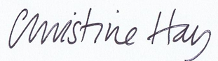
Signed by Author

Signed by copyright holder(s) of image(s) character,

Additional photographs, maps or other images

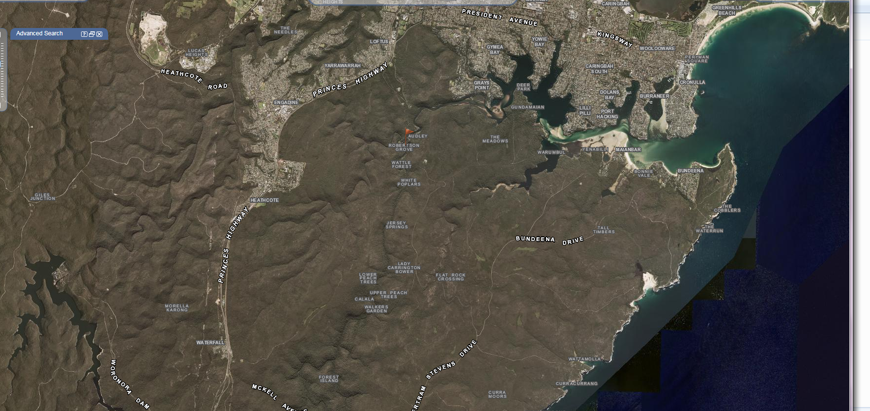

SIX Map plan illustrating the RNP

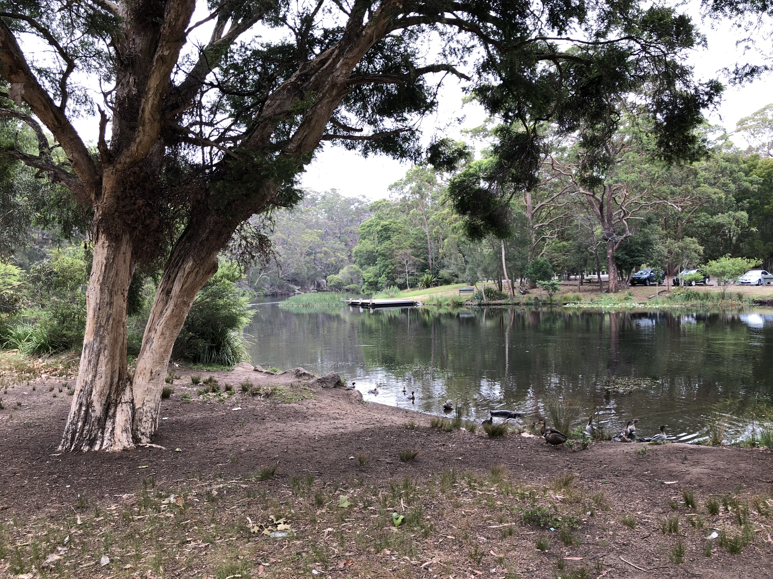
Image of recreation area near Audley weir
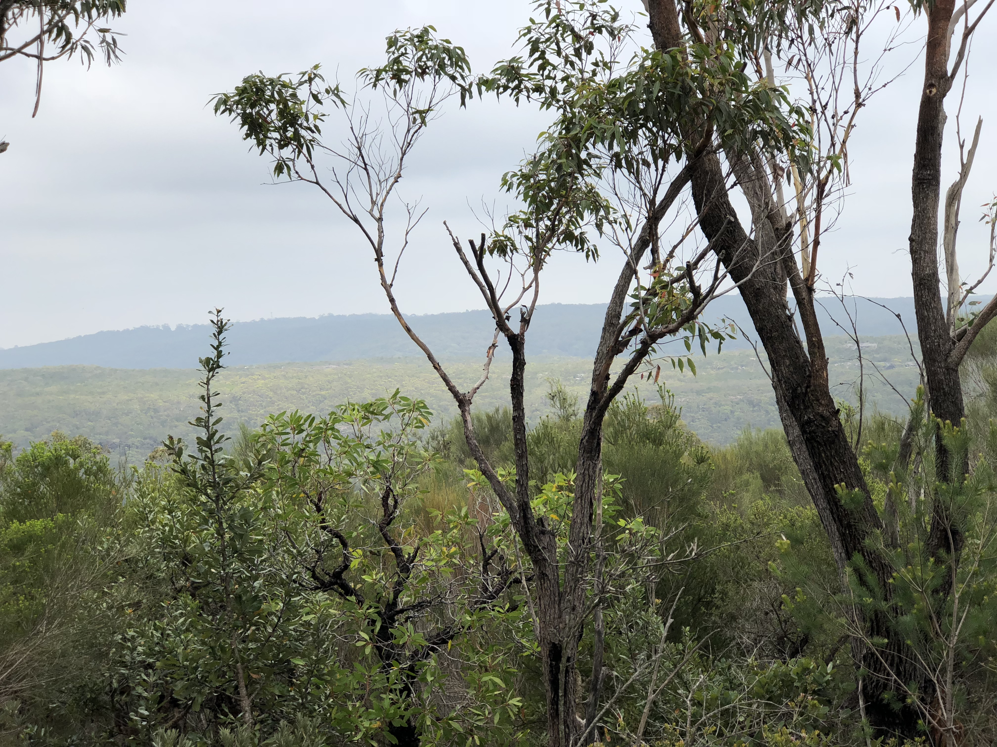
Chinaman’s helipad view to the Yarrawarrah Ridgeline and western horizon.
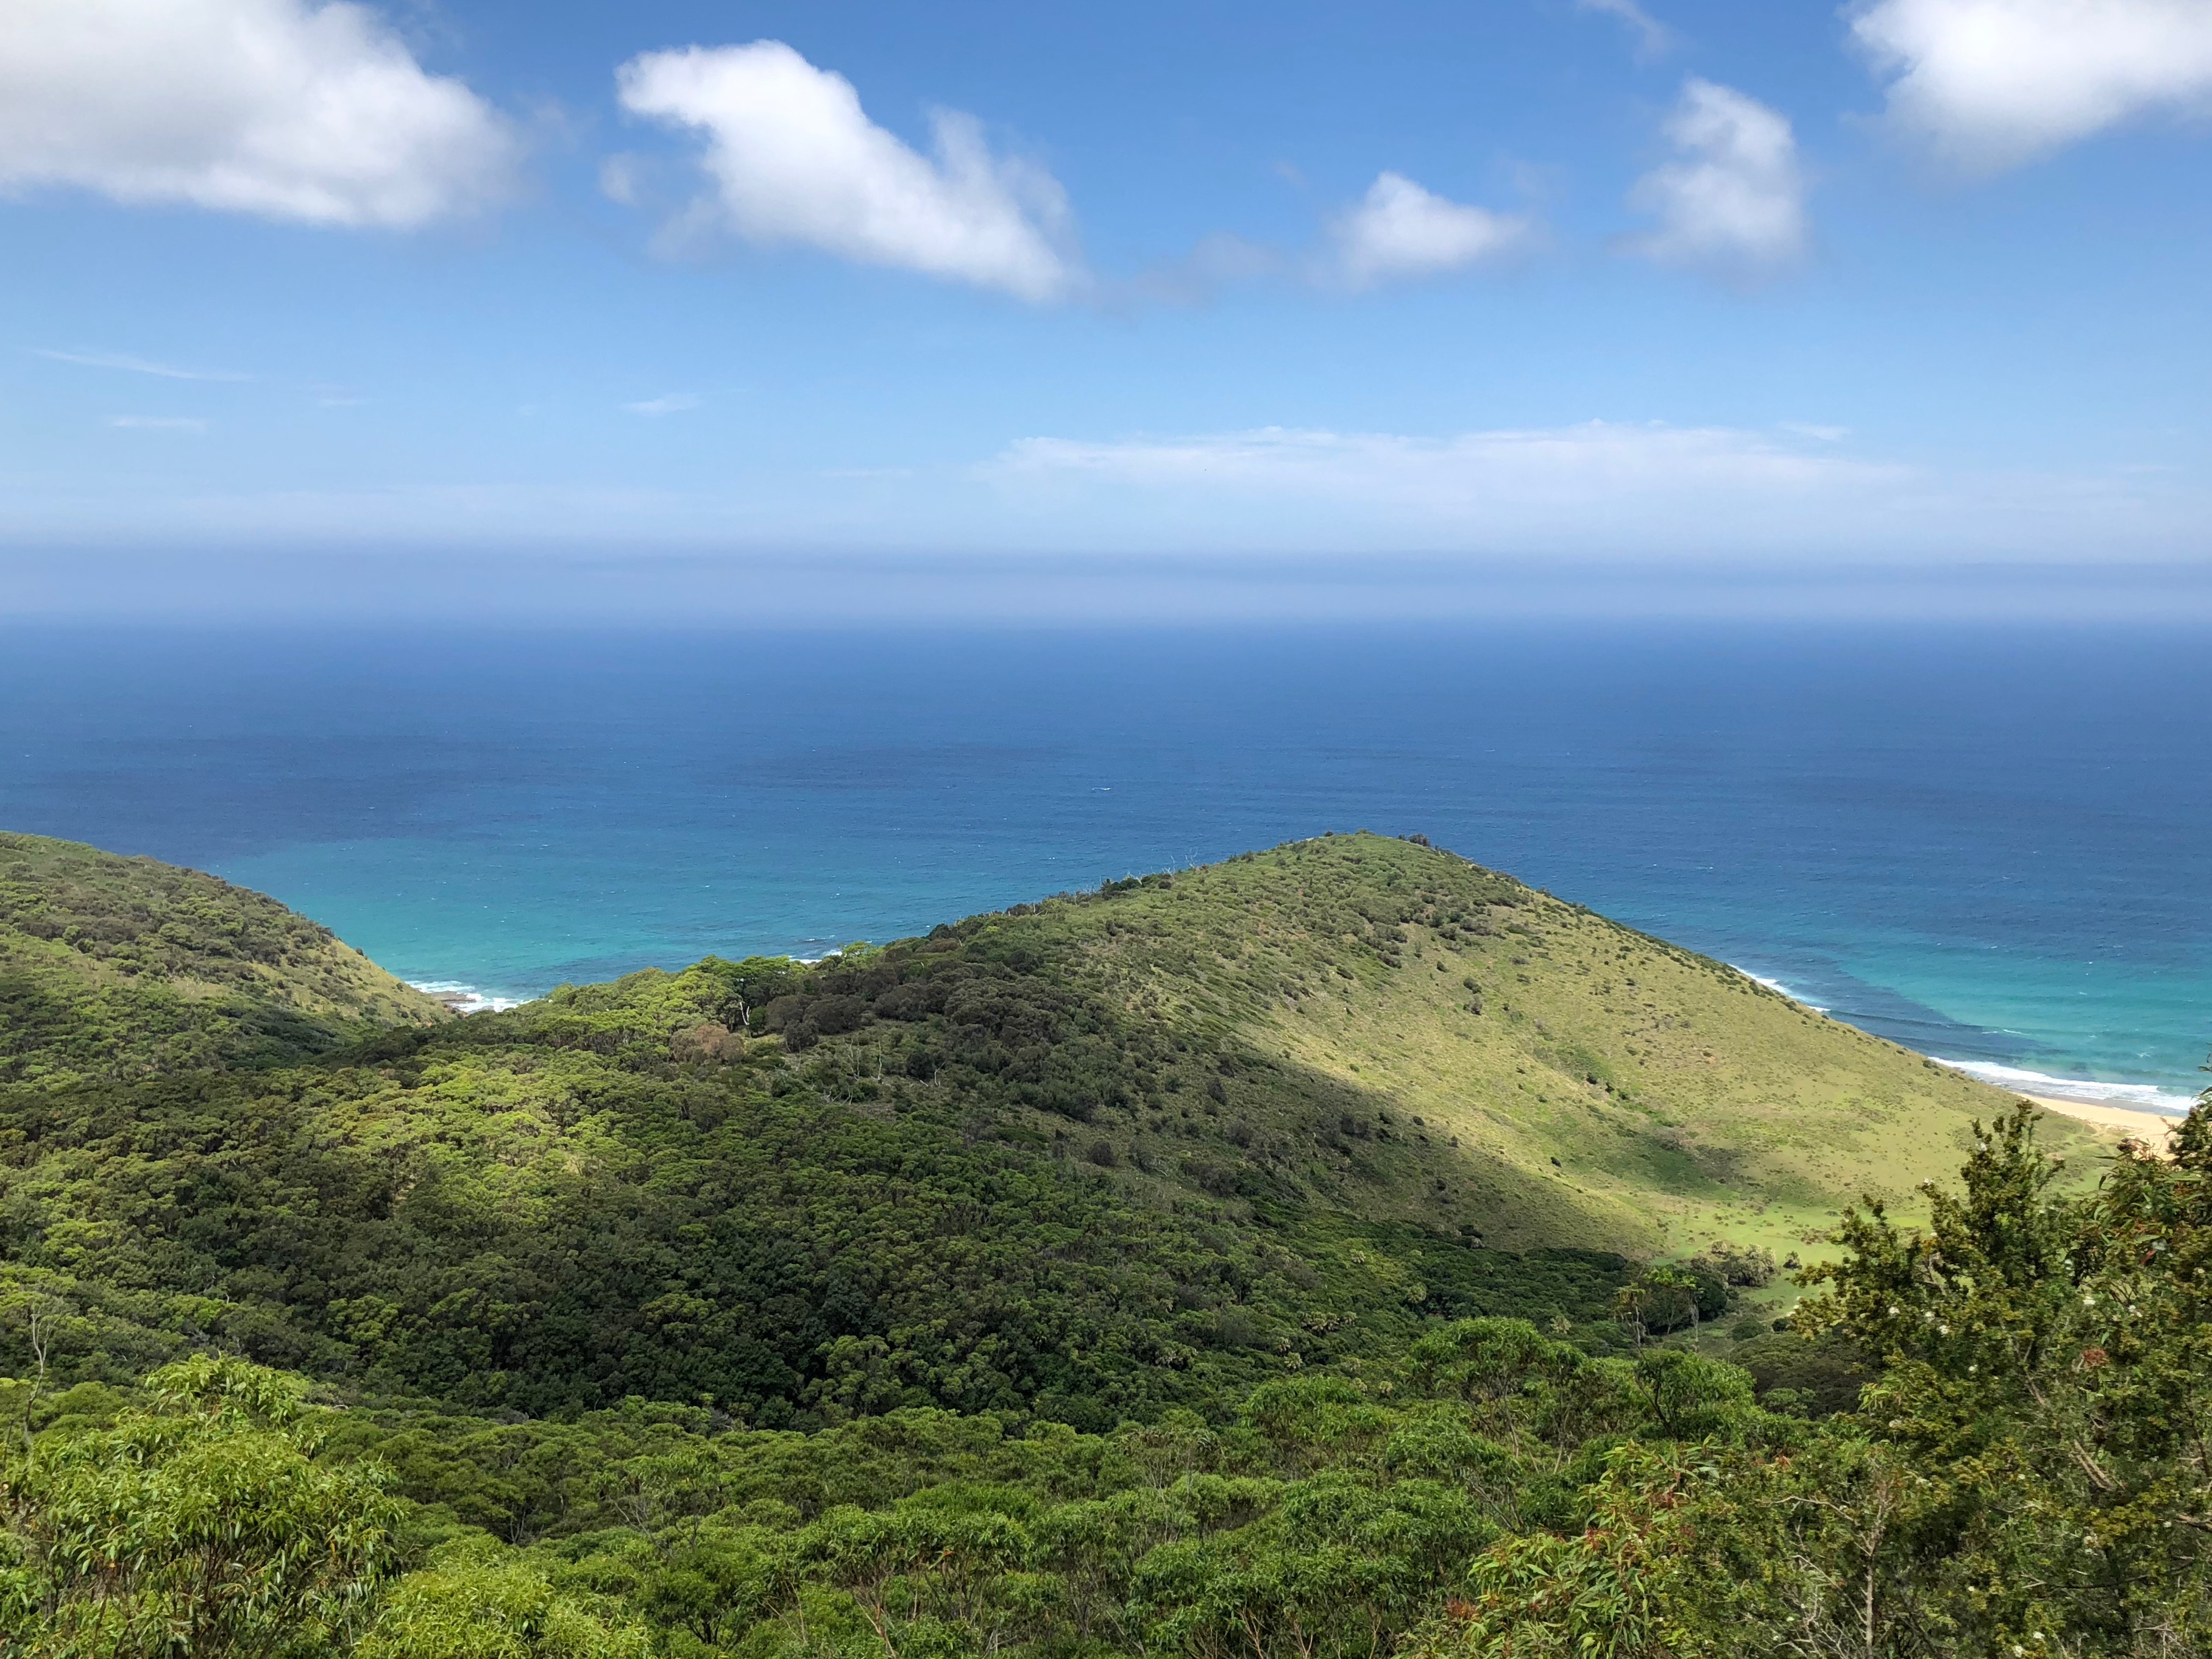
View over Thelma Ridge towards Garie from Governor Game Lookout
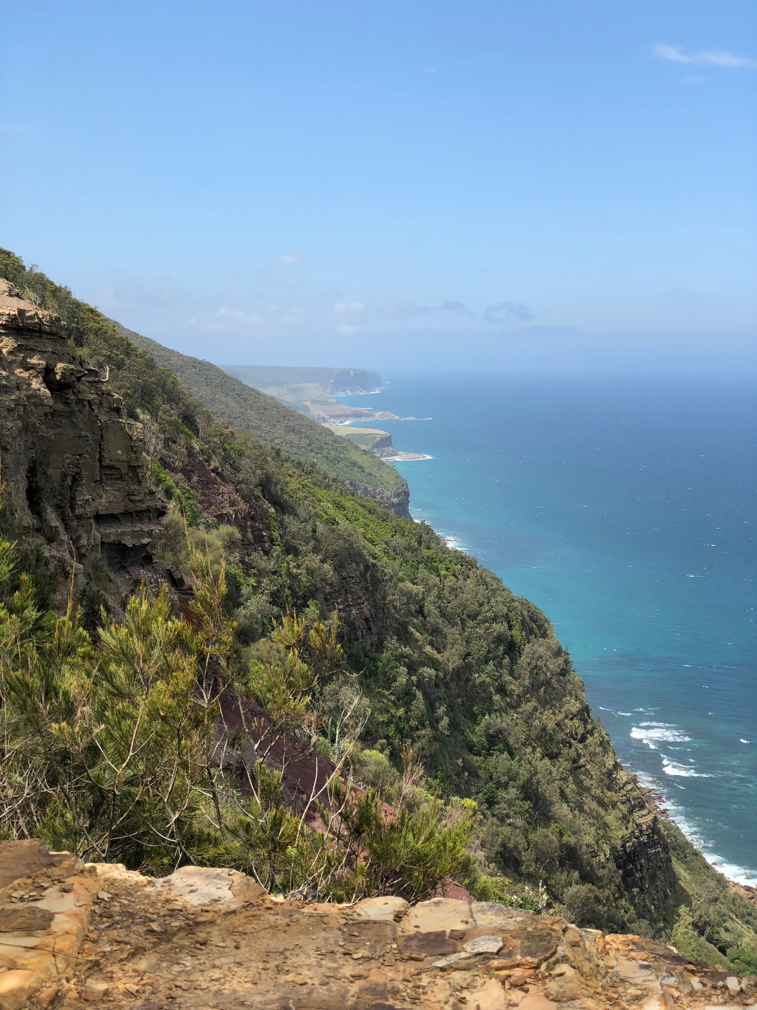
Northern view along GRNP coastline near Otford Lookout
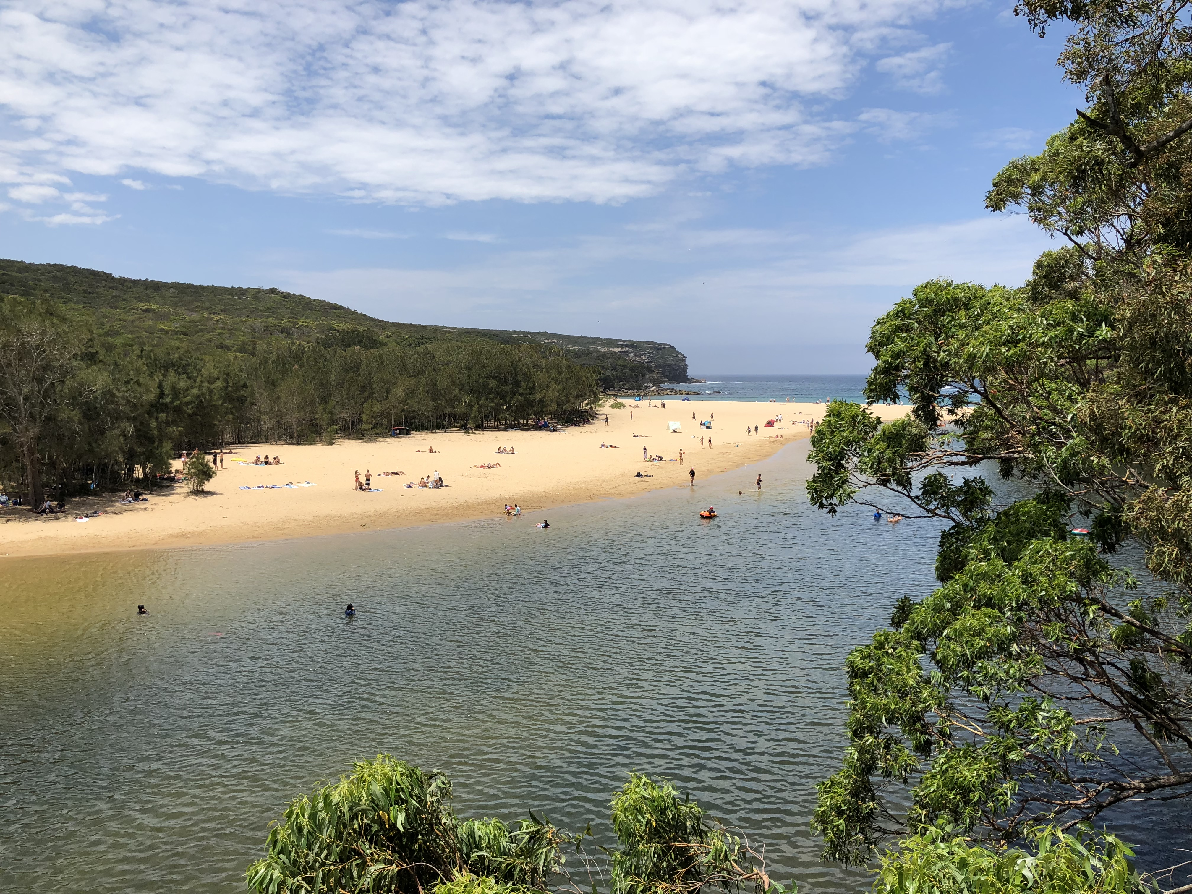
View of lagoon at Wattamolla
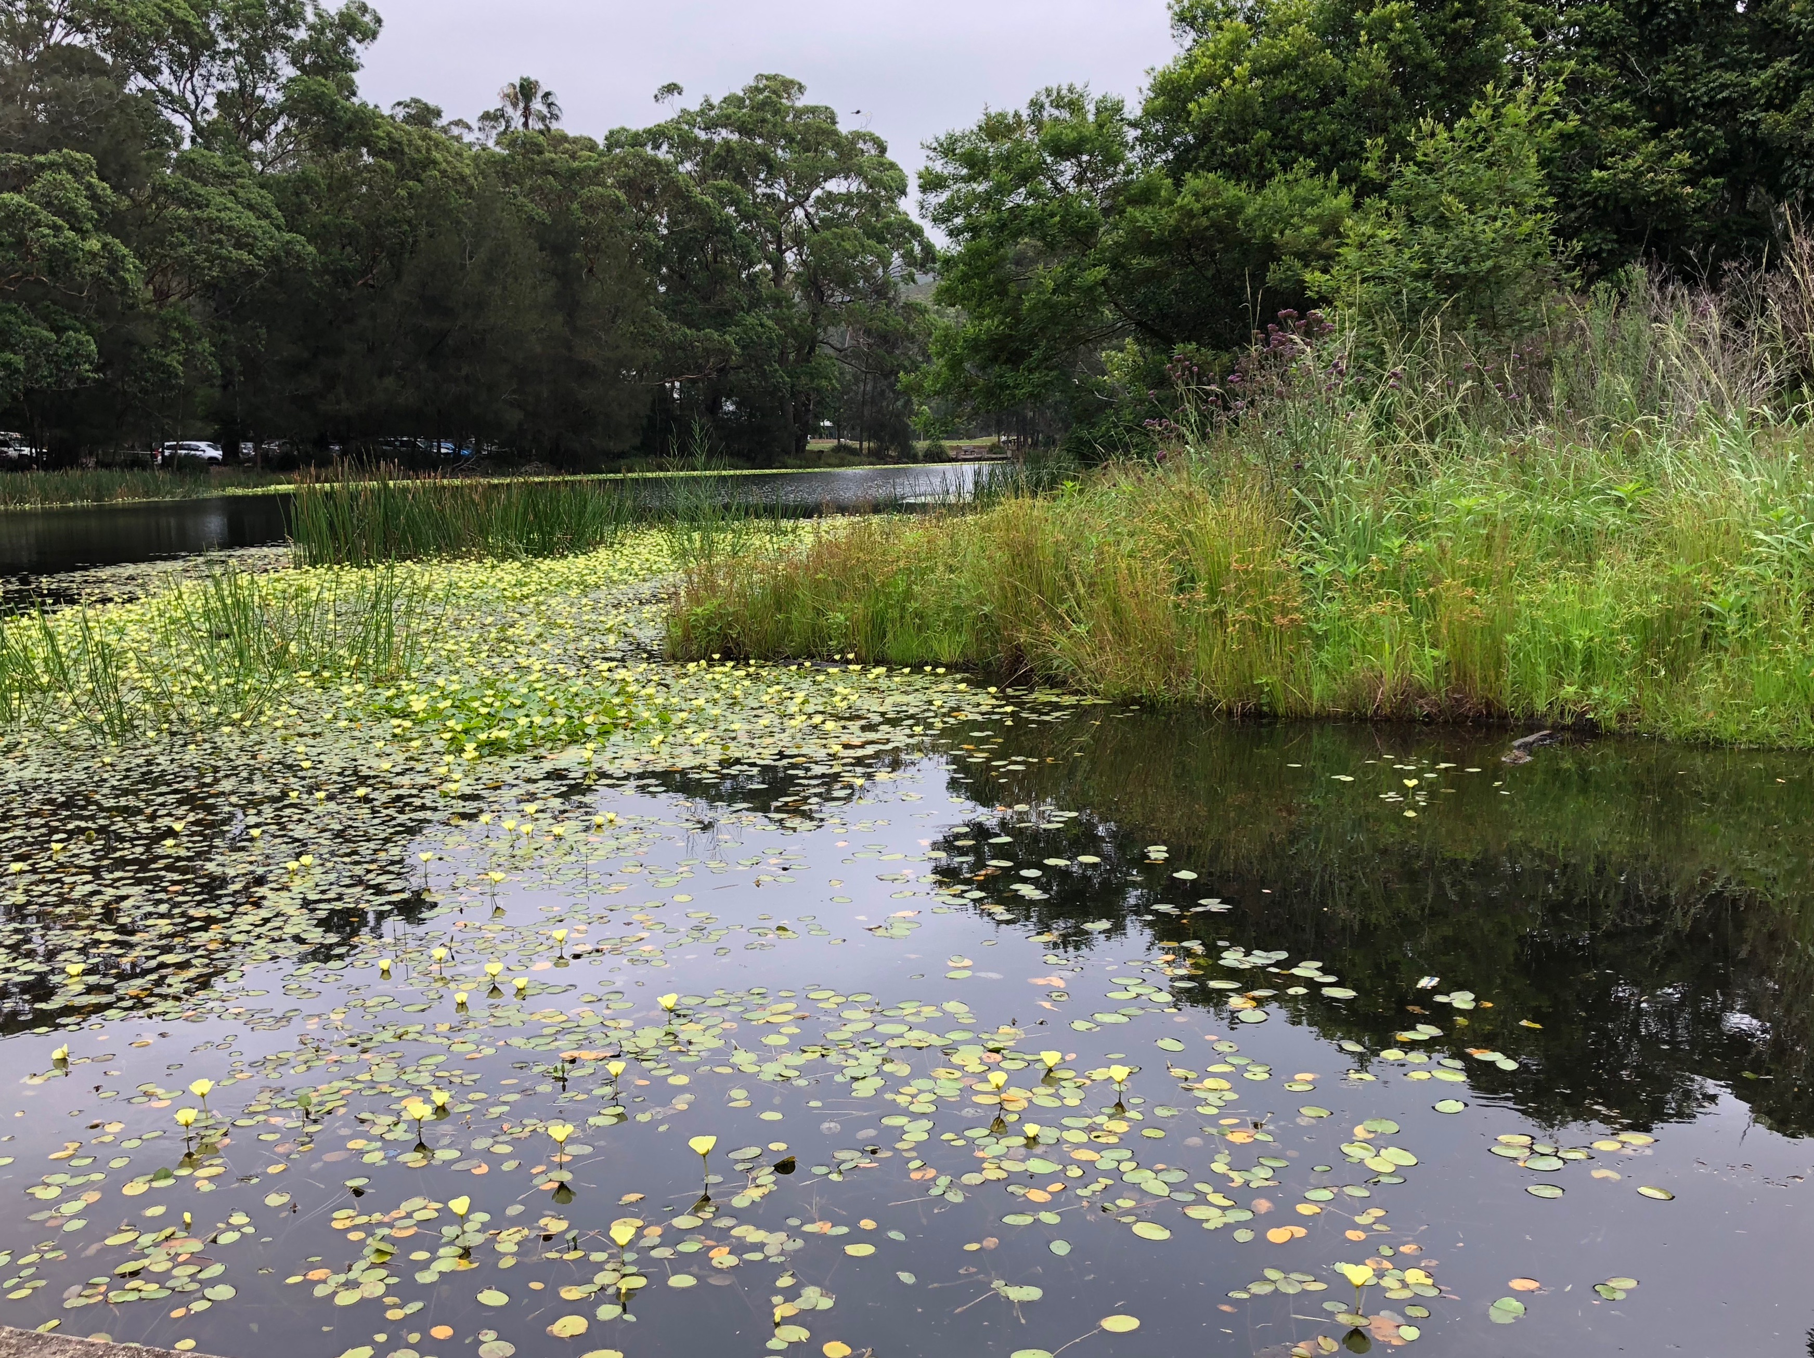
View from Audley Weir looking west
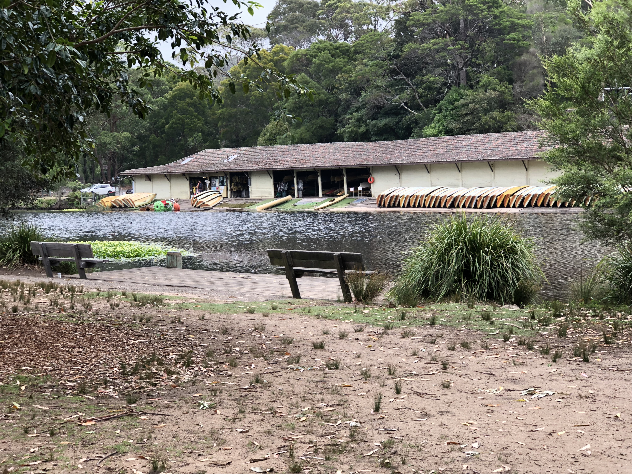
Boatshed at Audley Weir

https://www.northsydney.nsw.gov.au/Waste_Environment/Bushland_Wildlife/Biodiversity/2010_Natural_Area_Survey
Dr Geoff Mosley, THE FIRST NATIONAL PARK A Natural For World Heritage, Envirobook, Sutherland Shire Environment Centre Inc, Sutherland, 2012, includes Heathcote National Park and Garawarra State Conservation Area.
http://www.nationalparks.nsw.gov.au/visit-a-park/parks/royal-national-park accessed 2/03/2018
Val Attenbrow, Sydney’s Aboriginal Past, UNSW Press book, 2010, p.103.
Attenbrow, Sydney’s Aboriginal Past, p.177, pp.123-124.

